# Diagram, text Description automatically generated[https://avatars2.githubusercontent.com/u/4156894?v=3&s=100](http://www.calstatela.edu/centers/hipic) CIS5560 Term Project Tutorial

**Authors:** Anusha Valasapalli

Naga Sai Lohitha Karmuru

Rishabh Shah

Wethanie Law

**Instructor:** Jongwook Woo

**Date: 05/22/2023**

**Lab Tutorial**

Anusha Valasapalli (avalasa@calstatela.edu)

Naga Sai Lohitha Karmuru (nkarmur@calstatela.edu)

Rishabh shah ([rshah39@calstatela.edu](mailto:rshah39@calstatela.edu))

**USA Used Car Dataset**

**Predictive Analysis using machine learning models in Spark ML**

**Objectives**

The objective of the lab is to build a model that predicts the price of the used cars considering the features of the details of the vehicle using the following machine learning algorithms:

**Used Car Price Prediction**

Linear Regression

Random Forest Regression

Gradient Boost Tree Regression

Factorization Machines Regression

Logistic Regression Classification

**Predicting whether the customer can buy this car or not?**

Logistic Regression

You will learn how to build the above-listed regressions to predict the price of the car and whether the price is a fair deal.

**Platform Specifications: -**

**Version:** 3.2.1

**CPU Speed:** 2.40 GHz

**# of CPU cores:** 4

**# Number of nodes:** 3

**Total Memory Size:** 481GB

**Dataset Specifications: -**

**Dataset Name:** US Used Car Dataset

**Dataset Size:** 2 GB

**Dataset URL:** <https://www.kaggle.com/datasets/ananaymital/us-used-cars-dataset>

**Dataset Format:** CSV

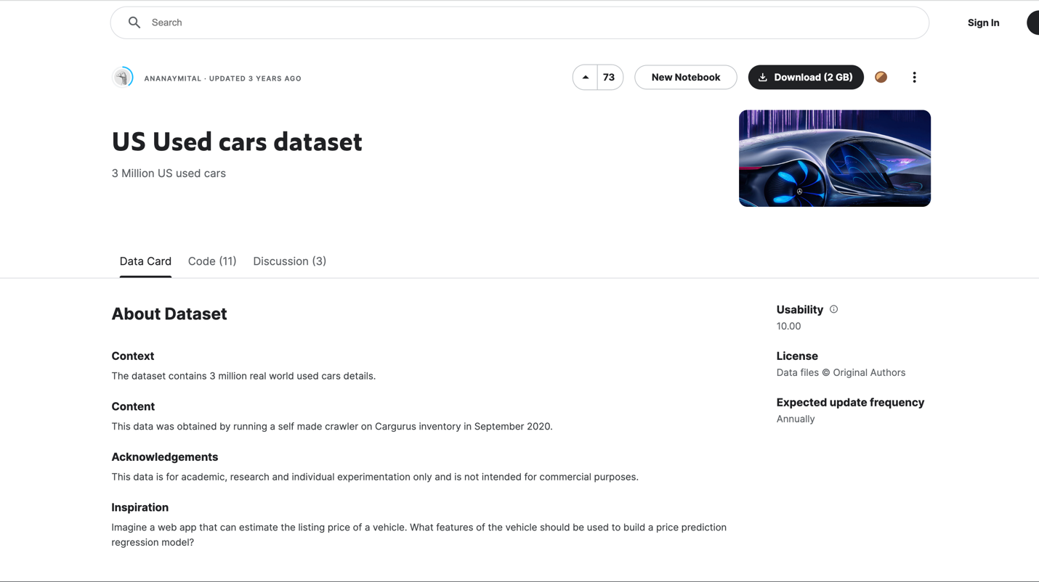

**Step 1: Get data manually from the Data source.**

**We first need to Download the dataset from Kaggle.**

1. Log in to Kaggle.

2. It is showing as a 2GB dataset with 9.9 GB. I downloaded the 9.9 GB csv dataset file from Kaggle.

3. Using the below code, slice the 33 MB of data from the above 9.9 GB csv and use that 33 MB file in the Databricks.

4. Using the below code, remove 2 GB of data from the 9.9 GB csv and use that 2 GB file in the spark-submit.

split -l 1000000 -d pricedata.csv ppd-

**Step 2: Upload data to Databricks.**

1)Log into data bricks using the below URL.

[https://community.cloud.databricks.com/?o=999471079023550#](https://community.cloud.databricks.com/?o=999471079023550)

**Step 3: Create a cluster in the data bricks.**

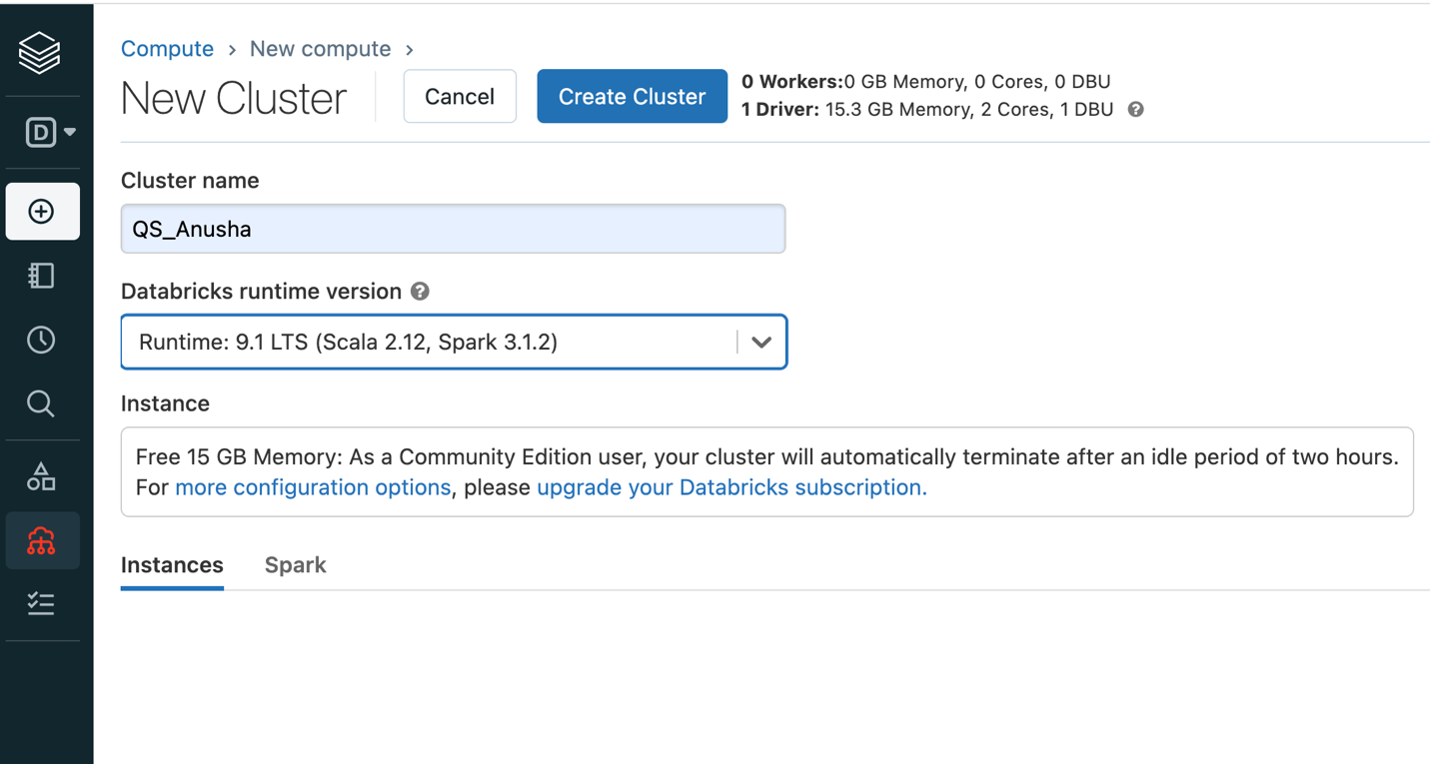

**Step 4: Upload the US Used Car dataset CSV file into the Databricks data and click Create notebook.**

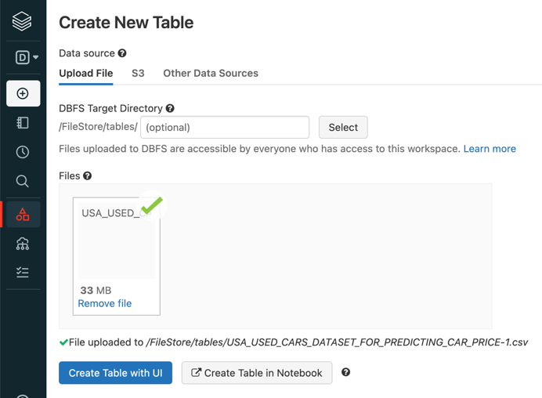

Once the file is uploaded, you can see Create Table in Notebook. Select “Create Table in Notebook.” It automatically generates a Spark and markdown codes in the notebook, which reads the data.

File and display it.

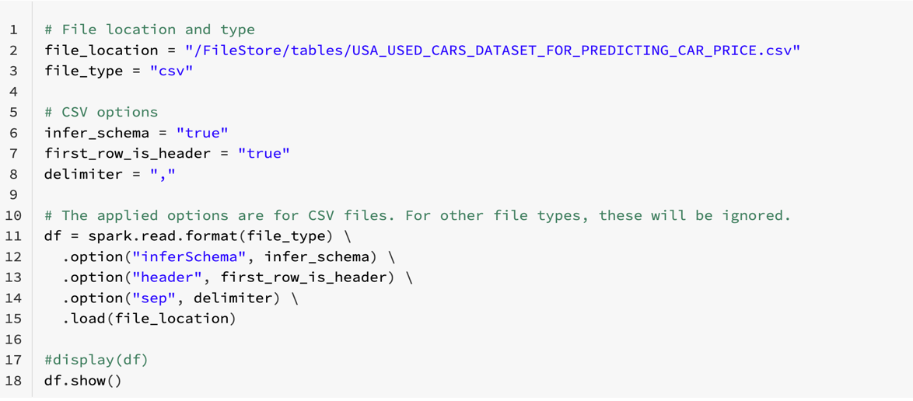

**Step 5: Create a temporary view of the table to use as a table name of Spark SQL.**

temp_table_name = "USA_USED_CARS_DATASET_FOR_PREDICTING_CAR_PRICE_csv"

df. createOrReplaceTempView(temp_table_name)

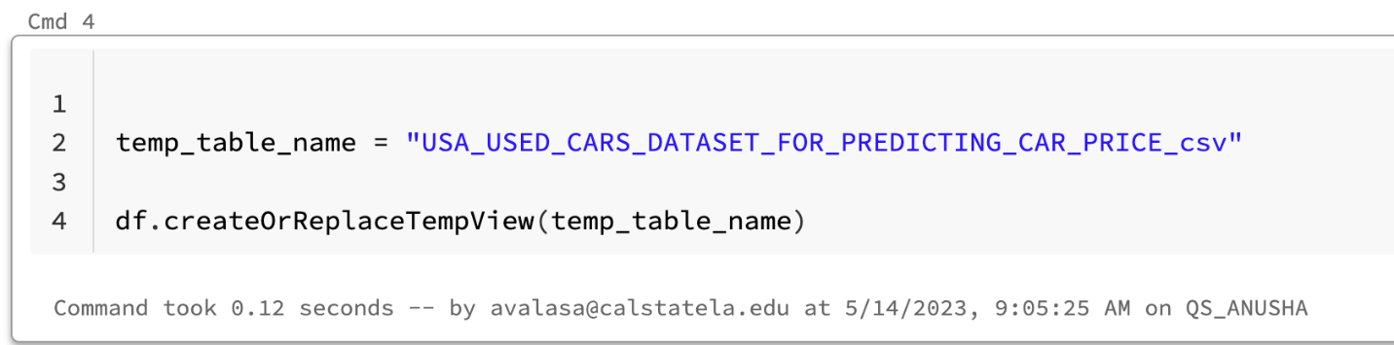

**Step 6: To see the data in the CSV file use this code df. take(10)**

df.take(10)

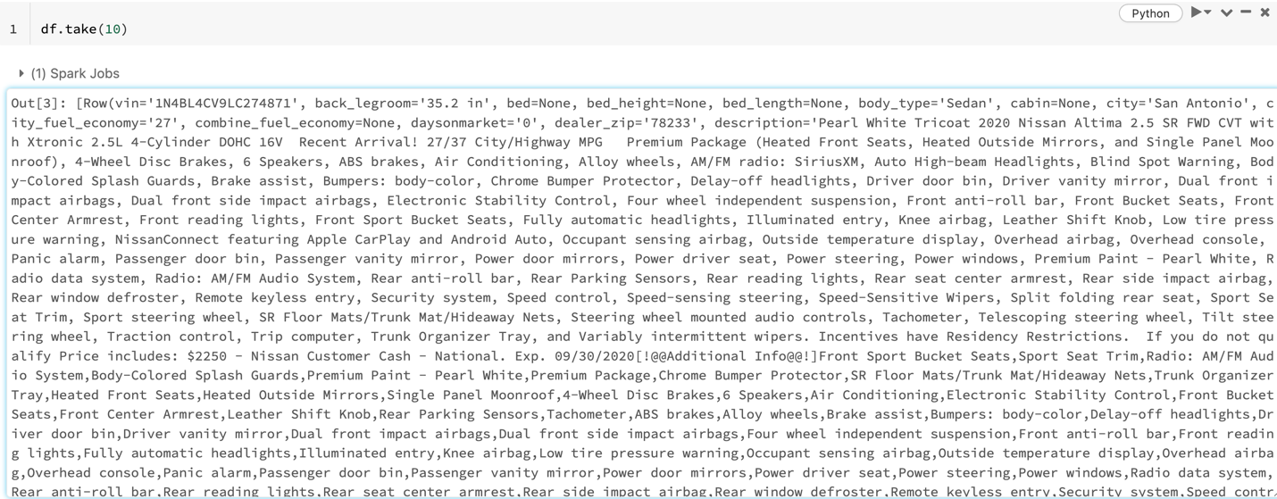

**Step 7: To check the data type of the parameter use the below code**

df.dtypes

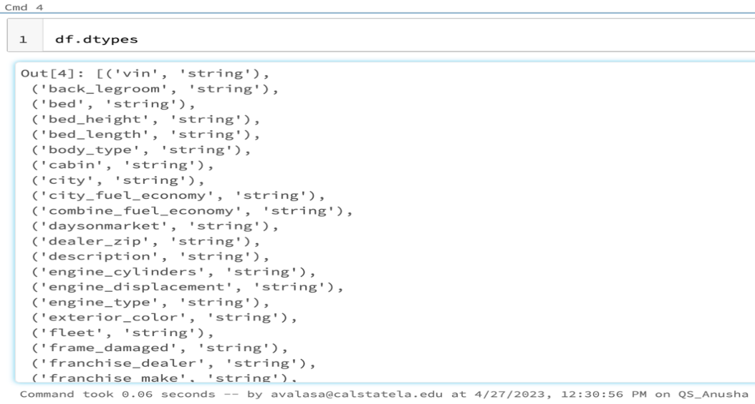

**Step 8: Import the statements**

import pyspark

from pyspark.sql import SparkSession

from pyspark.sql.functions import col, lit

from pyspark.sql.types import StructType, StructField, StringType,IntegerType

from pyspark.sql.types import *

from pyspark.sql.functions import *

from pyspark.ml.regression import RandomForestRegressor, LinearRegression, GBTRegressor

from pyspark.ml.linalg import Vectors

from pyspark.ml import Pipeline

from pyspark.ml.tuning import ParamGridBuilder,TrainValidationSplit, CrossValidator

from pyspark.ml.tuning import CrossValidator

from pyspark.ml.classification import LogisticRegression

from pyspark.ml.feature import VectorAssembler, StringIndexer, VectorIndexer, MinMaxScaler

from pyspark.ml.evaluation import BinaryClassificationEvaluator

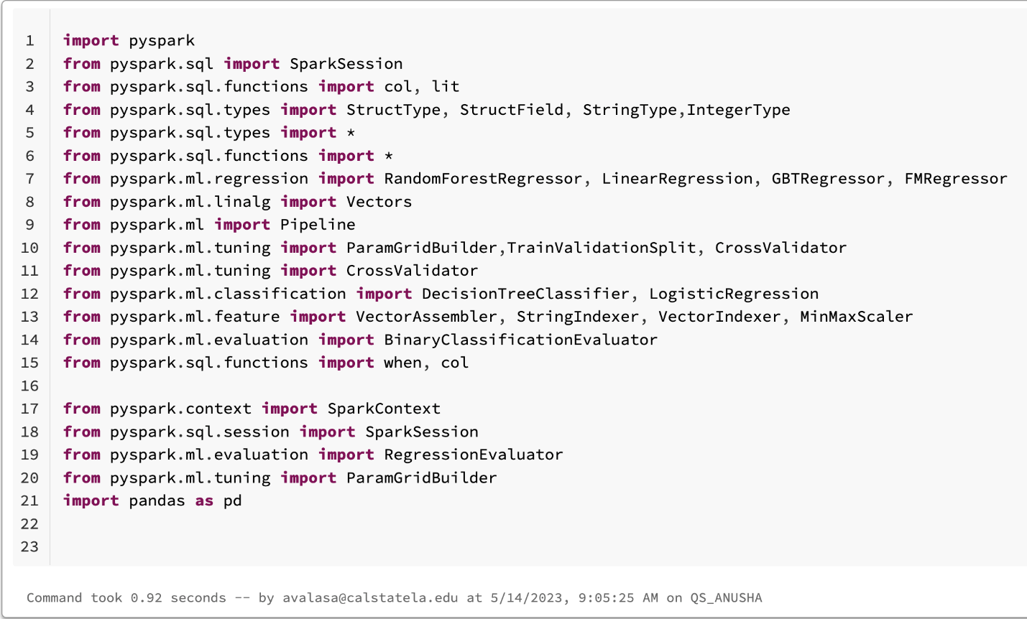

**Step 9: Typecast string to int or float**

df2 = df.withColumn("year",col("year").cast("int")).withColumn("city_fuel_economy",col("city_fuel_economy").cast("float")).withColumn("price",col("price").cast("float")).withColumn("mileage",col("mileage").cast("float")).withColumn("owner_count",col("owner_count").cast("int")).withColumn("latitude",col("latitude").cast("float")).withColumn("highway_fuel_economy",col("highway_fuel_economy").cast("float")).withColumn("daysonmarket",col("daysonmarket").cast("int")).withColumn("dealer_zip",col("dealer_zip").cast("int")).withColumn("engine_displacement",col("engine_displacement").cast("int")).withColumn("listing_id",col("listing_id").cast("int")).withColumn("savings_amount",col("savings_amount").cast("int")).withColumn("sp_id",col("sp_id").cast("int")).withColumn("seller_rating",col("seller_rating").cast("int"))

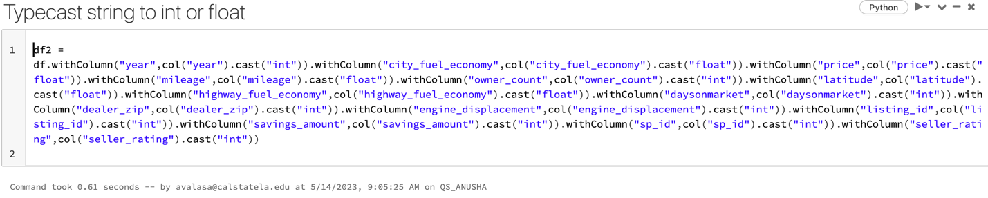

**Step 10: After converting the string to Int and float, see the results with the following command.**

(df2.select("year", "city_fuel_economy", "price", "mileage", "owner_count", "latitude", "highway_fuel_economy", "daysonmarket", "dealer_zip", "engine_displacement", "listing_id", "savings_amount", "seller_rating", "sp_id","frame_damaged","theft_title", "has_accidents", "frame_damaged", "theft_title").limit(10)).show()

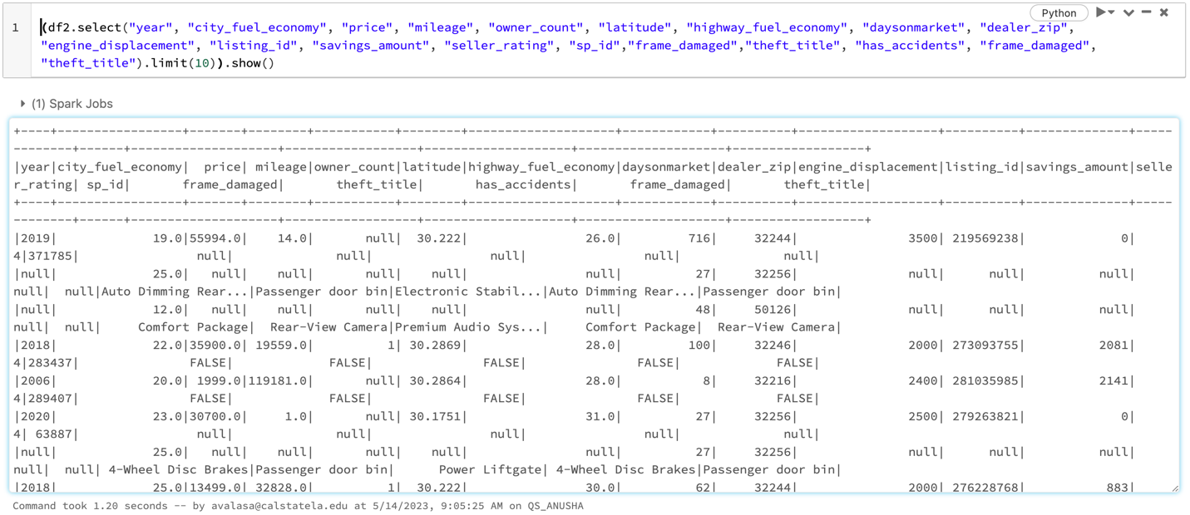

**Step 11: Convert dataset to pandas to do the modifications**

df3 = df2.toPandas()

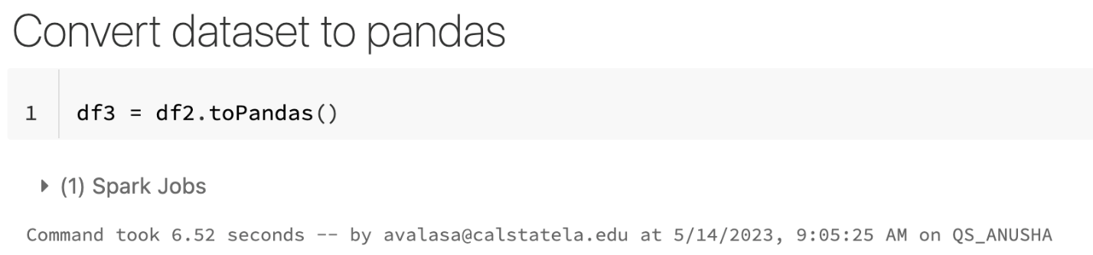

**Step 12:Remove the null values and filter the price to more than 100,000**

df2.na.drop(subset=["price", "year", "city_fuel_economy", "mileage", "owner_count", "highway_fuel_economy", "daysonmarket", "dealer_zip", "engine_displacement", "listing_id", "savings_amount", "seller_rating", "sp_id", "has_accidents", "frame_damaged", "theft_title"])

df222 = df2.filter(col("price") < 100000)

df22 = df222.select("year", "city_fuel_economy", col("price").alias("label"), "mileage", "owner_count", "latitude", "highway_fuel_economy", "daysonmarket", "dealer_zip", "engine_displacement", "listing_id", "savings_amount", "seller_rating", "sp_id", "has_accidents", "frame_damaged", "theft_title")

df22.show()

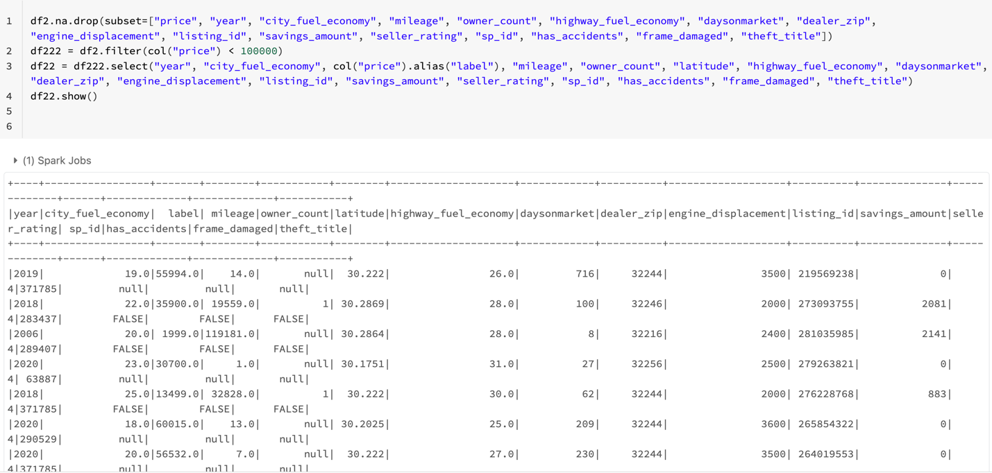

**STEP 13:Split the data into Train and Test datasets.**

splits = df22.randomSplit([0.7, 0.3])

train = splits[0]

test = splits[1]

train_rows = train.count()

test_rows = test.count()

print("TRAINING ROWS:", train_rows, "TESTING ROWS:", test_rows)

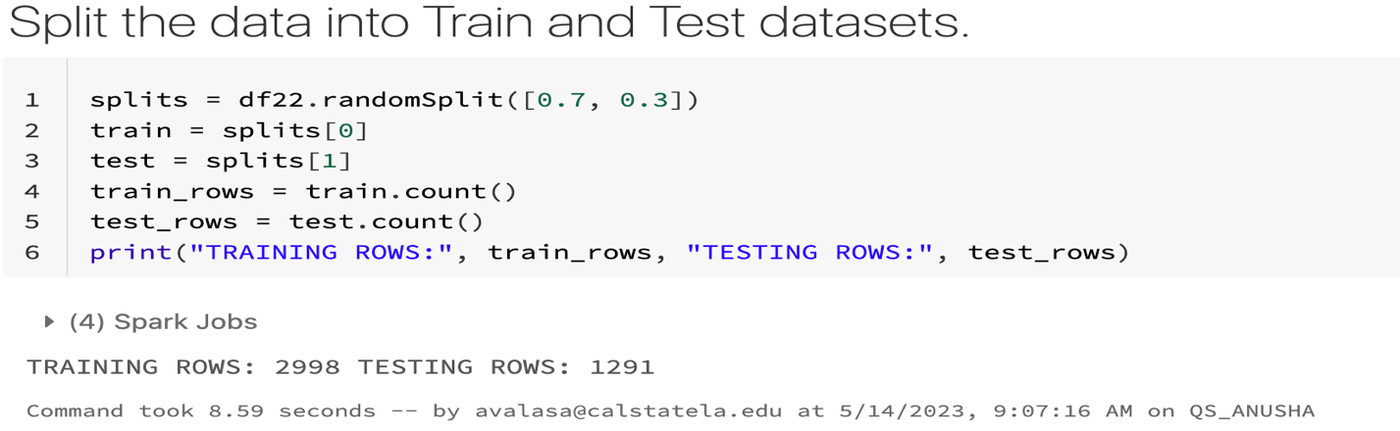

**Working with Machine Learning Algorithms: -**

**We did tune all algorithms with cross-validation and Train Validation Split**

**Algorithm 1: Linear Regression**

**LINEAR REGRESSION CROSS-VALIDATION**

**1) Create a vector assembler with input columns**

lr_assembler = VectorAssembler(inputCols = ["year", "city_fuel_economy", "mileage", "owner_count", "highway_fuel_economy", "engine_displacement", "savings_amount"], outputCol="features").setHandleInvalid("skip")



**2) Train a Regression Model**

lr= LinearRegression(labelCol="label") #,featuresCol="features",maxIter=10

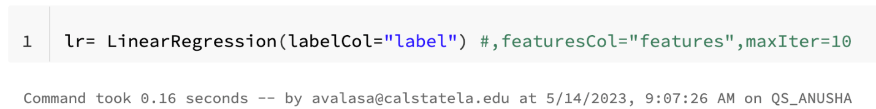

**3) Create a parameter combination, which is to tune the model.**

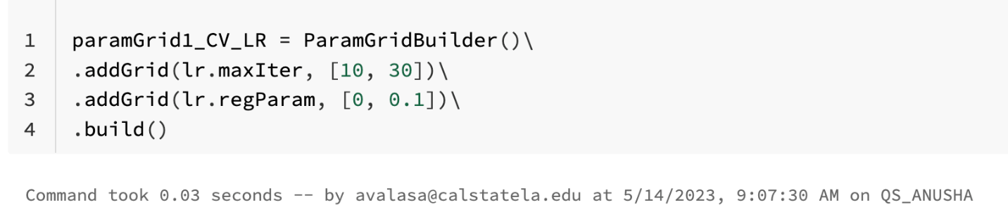

**4)** **Create an evaluator to evaluate a model with R2**

from pyspark.ml.evaluation import RegressionEvaluator

lr_CV_evaluator = RegressionEvaluator(predictionCol="prediction", \

labelCol="label",metricName="r2")

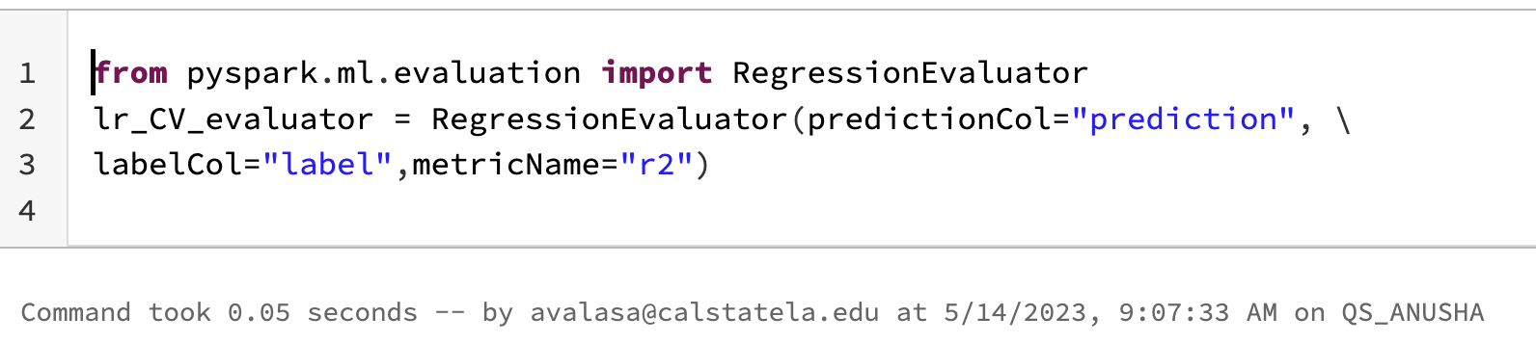

**5) Create a pipeline, which is to sequence the tasks.**

#we can use same pipeline_lr for both cv and tvs

pipeline_lr = Pipeline(stages=[lr_assembler, lr])

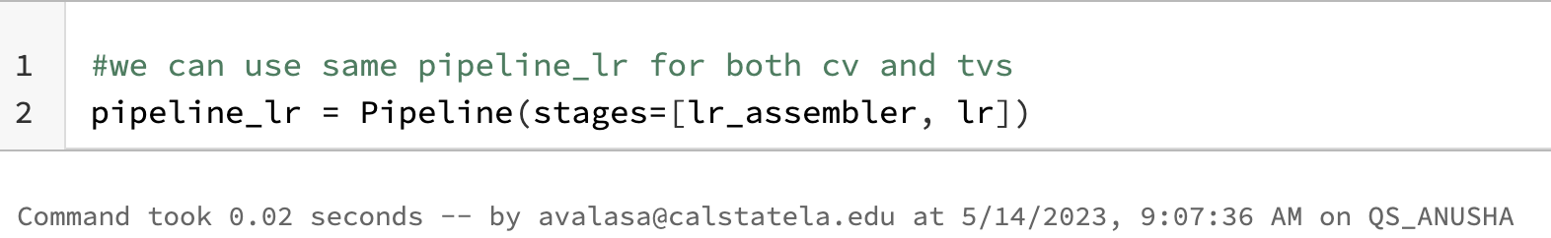

6) **Create a cross-validator to tune the model for the generalization. The default folds are 3.**

cv_lr = CrossValidator(estimator=pipeline_lr, evaluator=lr_CV_evaluator, estimatorParamMaps=paramGrid1_CV_LR)



**7)Build a model with the train Dataframe of cross validator**

model_CV_LR = cv_lr.fit(train)

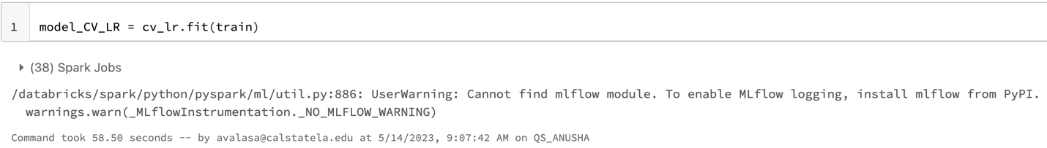

**8)Predict price using Linear Regression with Cross Validation**

prediction_CV_lR = model_CV_LR.transform(test)

predicted_CV_lR = prediction_CV_lR.select("features", "prediction", "label")

predicted_CV_lR.show(10)

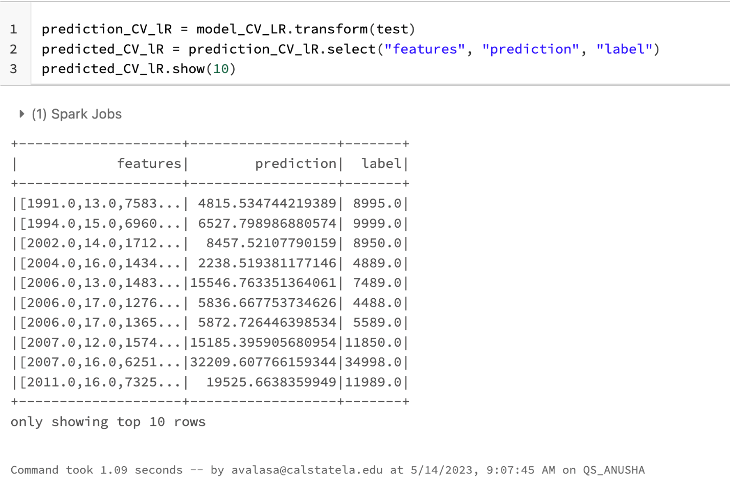

**9)** **R2 and RMSE For LR_CV**

from pyspark.ml.evaluation import RegressionEvaluator

lr_evaluator_CV_r2 = RegressionEvaluator(predictionCol="prediction", \

labelCol="label",metricName="r2")

lr_evaluator_CV_rmse = RegressionEvaluator(labelCol="label", predictionCol="prediction", metricName="rmse")

#R2 and RMSE For LR_CV

print("r2 For LR_CV: %.2f" % lr_evaluator_CV_r2.evaluate(prediction_CV_lR))

print("RMSE For LR_CV: %.2f" % lr_evaluator_CV_rmse.evaluate(prediction_CV_lR))

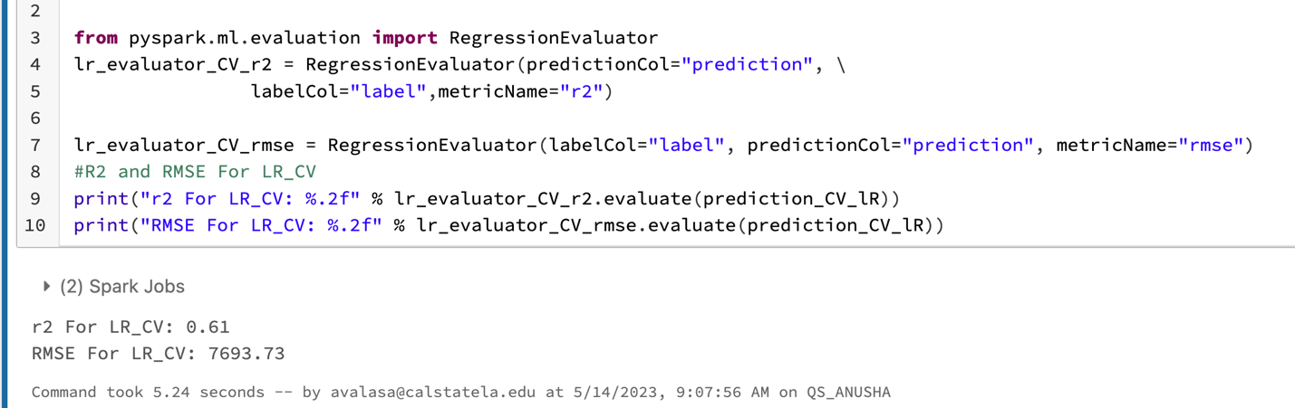

RESULT: R2 For LR_CV: 0.61

RMSE For LR_CV: 7693.73

LR_TV_Data_Training_Time = 58.50 seconds

**LINEAR REGRESSION TRAIN VALIDATION:**

Did the same steps as above with the Cross Validation and used the same lr and lr-assembler which are identical for both cross-validation and train validation split.

**1) Create a parameter combination to tune the model.**

paramGrid2_TV_LR = ParamGridBuilder()\

.addGrid(lr.maxIter, [10, 40])\

.addGrid(lr.regParam, [0.1, 1.0])\

.build()

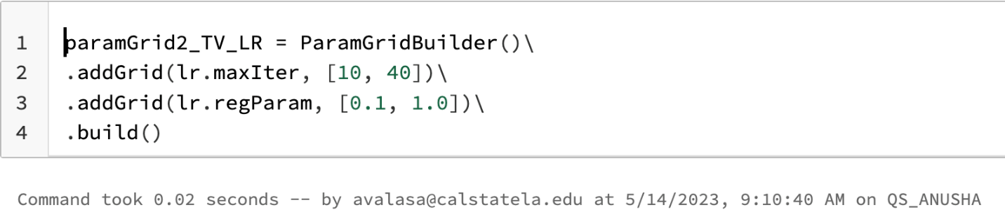

**2)** **Create an evaluator to evaluate a model with R2**

from pyspark.ml.evaluation import RegressionEvaluator

lr_tv_evaluator = RegressionEvaluator(predictionCol="prediction", \

labelCol="label",metricName="r2")

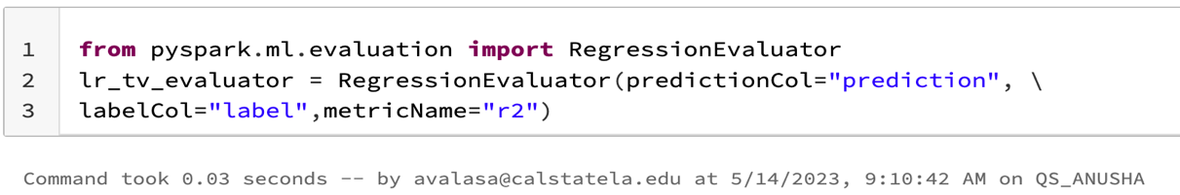

**3) Create a Tarin_Validation Split to tune the model for the generalization. The default folds are 3.**

tv_lr = TrainValidationSplit(estimator=pipeline_lr, evaluator=lr_tv_evaluator, estimatorParamMaps=paramGrid2_TV_LR, trainRatio=0.8)



**5) Build a model with the train Dataframe of cross validator**

model1_tv_lr = tv_lr.fit(train)

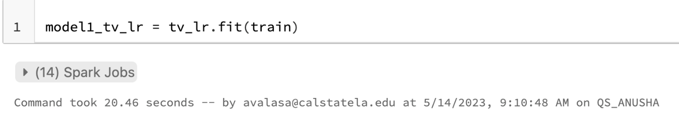

**6) Predicted price using Linear Regression Train Validation**

prediction_tv_lr = model1_tv_lr.transform(test)

predicted_tv_lr = prediction_tv_lr.select("features", "prediction", "label")

predicted_tv_lr.show(10)

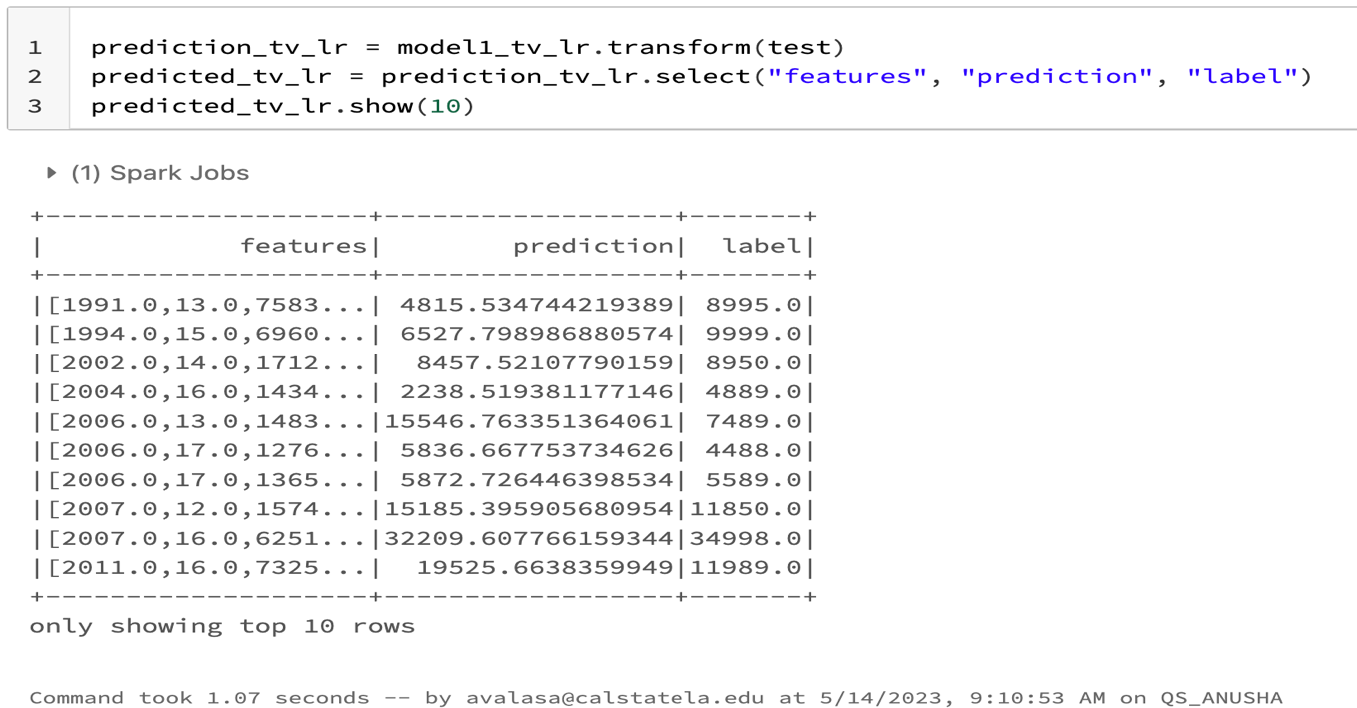

**7) R2 and RMSE For Linear Regression Train Validation**

from pyspark.ml.evaluation import RegressionEvaluator

lr_tv_evaluator_r2 = RegressionEvaluator(predictionCol="prediction", \

labelCol="label",metricName="r2")

lr_tv_evaluator_rmse = RegressionEvaluator(labelCol="label", predictionCol="prediction", metricName="rmse")

#R2 and RMSE For LR_TV

print("r2 For LR CV: %.2f" % lr_tv_evaluator_r2.evaluate(prediction_tv_lr))

print("RMSE for LT TV: %.2f" % lr_tv_evaluator_rmse.evaluate(prediction_tv_lr))

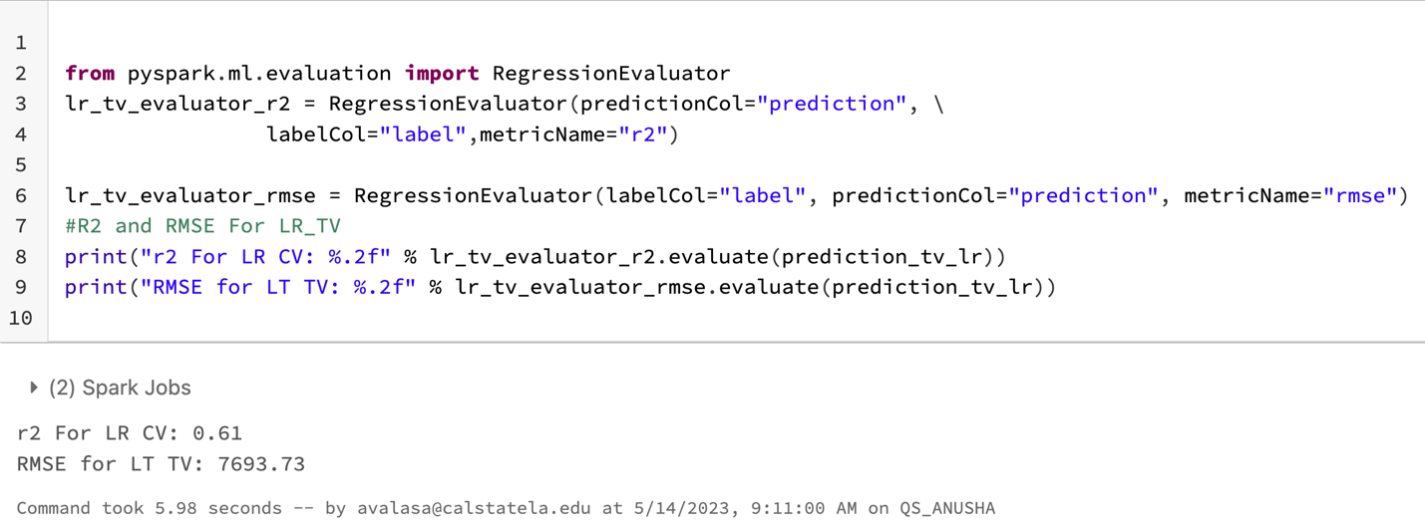

Result: R2 For LR TV: 0.61

RMSE for LT TV: 7693.73

LR_TV_Data_Training_Time = 20.46 seconds

**Algorithm 2: Gradient Boost Tree(GBT)**

**GBT Cross Validation:**

**1)Create a vector assembler with input columns**

gbt_assembler = VectorAssembler(inputCols = ["year", "city_fuel_economy", "mileage", "owner_count", "highway_fuel_economy", "engine_displacement", "savings_amount"], outputCol="features").setHandleInvalid("skip")



**2) Create GBT REgressor**

gbt = GBTRegressor(labelCol="label") #,featuresCol="features",maxIter=10

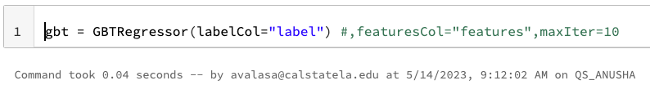

**3) Create ParamGridBuilder with different parameters**

paramGrid_CV_GBT = ParamGridBuilder()\

.addGrid(gbt.maxDepth, [2, 5])\

.addGrid(gbt.maxIter, [10, 20])\

.addGrid(gbt.minInfoGain, [0,0])\

.build()

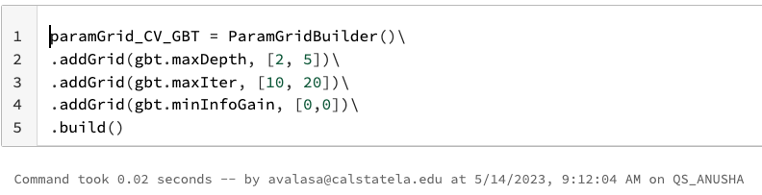

**4) Create an evaluator to evaluate a model with R2**

gbt_evaluator = RegressionEvaluator(predictionCol="prediction", \

labelCol="label",metricName="r2")

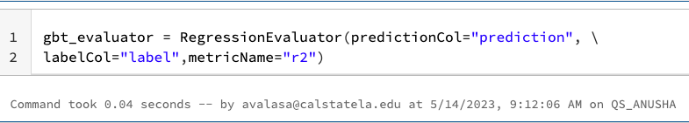

**5) Creating the Pipeline**

pipeline_GBT = Pipeline(stages=[gbt_assembler, gbt])

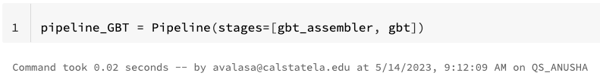

**6)** **create a cross-validator to tune the model for the generalization.**

GBT_CV = CrossValidator(estimator=pipeline_GBT, evaluator=gbt_evaluator, estimatorParamMaps=paramGrid_CV_GBT, numFolds = 3)



**7) creating a model to train**

model_GBT = GBT_CV.fit(train)

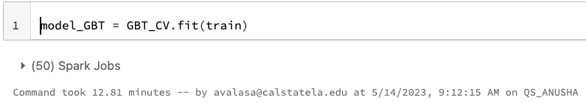

**8) Predicting the Price**

prediction_GBT = model_GBT.transform(test)

predicted_GBT = prediction_GBT.select("features", "prediction", "label")

predicted_GBT.show(10)

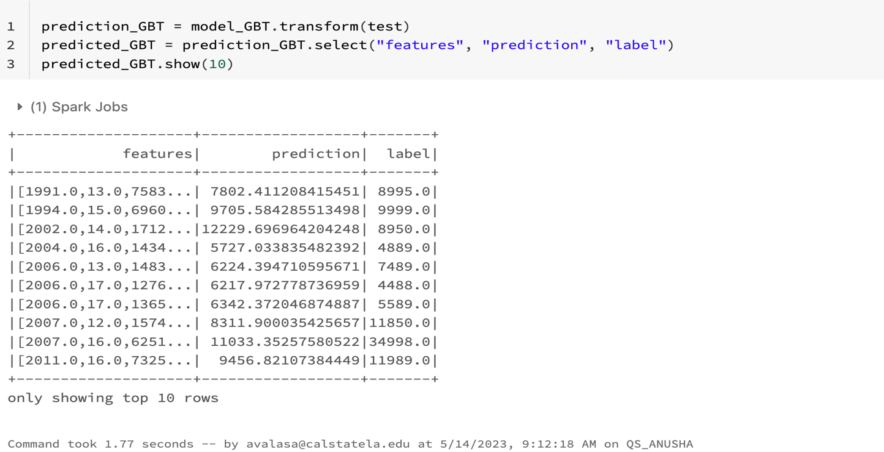

**9) R2 and RMSE for GBT Cross Validation**

gbt_evaluator_r2 = RegressionEvaluator(labelCol="label", predictionCol="prediction", metricName="rmse")

print("RMSE_GBT_CV: %.2f" % gbt_evaluator_r2.evaluate(prediction_GBT))

gbt_evaluator_rmse = RegressionEvaluator(predictionCol="prediction", \

labelCol="label",metricName="r2")

print("R2_GBT_CV: %.2f" % gbt_evaluator_rmse.evaluate(prediction_GBT)

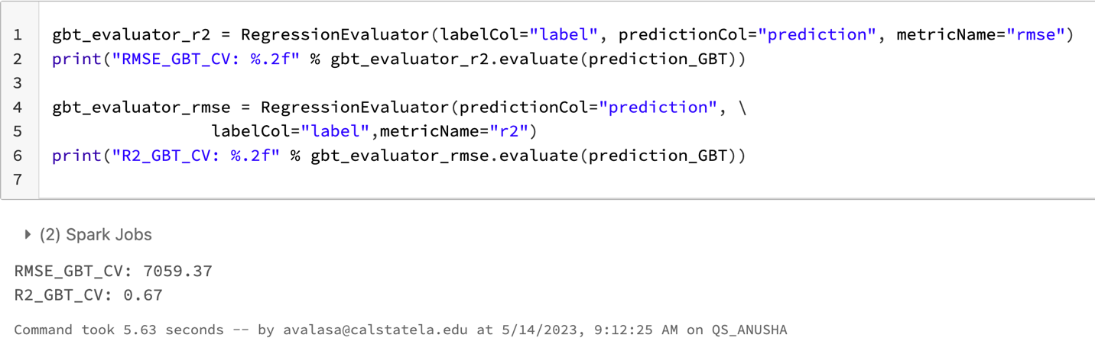

RMSE_GBT_CV: 7059.37

R2_GBT_CV: 0.67

Training time: 12.81 minutes

**GBT_Train_Validation: -**

**1)Create a Param Grid with different parameters**

paramGrid_TV_GBT = ParamGridBuilder()\

.addGrid(gbt.maxDepth, [2, 5])\

.addGrid(gbt.maxIter, [20, 40])\

.addGrid(gbt.maxBins, [15, 30])\

.addGrid(gbt.stepSize, [0.05, 0.1])\

.addGrid(gbt.minInfoGain, [0,0])\

.build()

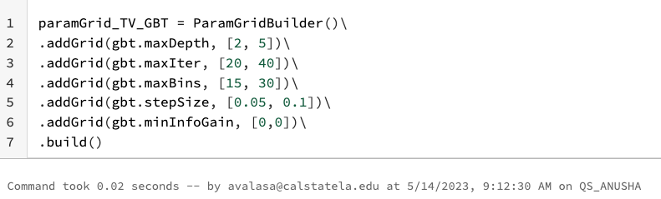

**2) Create Train Validation split for GBT**

GBT_TV = TrainValidationSplit(estimator=pipeline_GBT, evaluator=gbt_evaluator, estimatorParamMaps=paramGrid_TV_GBT, trainRatio=0.8)



**3) Train the Data**

model_GBT_TV = GBT_TV.fit(train)

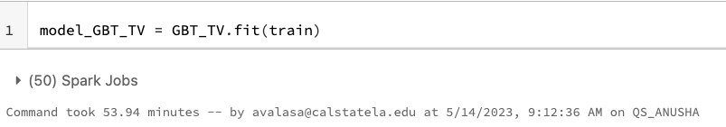

**4) Predicting the Price**

prediction_GBT = model_GBT_TV.transform(test)

predicted_GBT = prediction_GBT.select("features", "prediction", "label")

predicted_GBT.show(10)

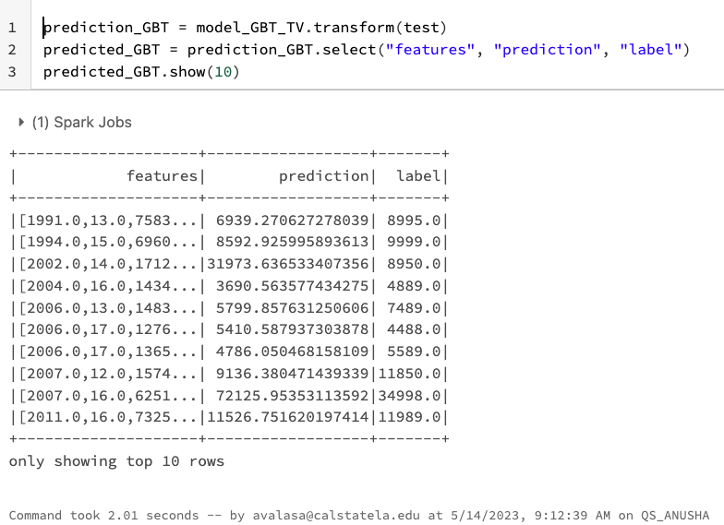

**GBT Train Validation Split RMSE & R2**

gbt_evaluator_rmse = RegressionEvaluator(labelCol="label", predictionCol="prediction", metricName="rmse")

print("RMSE_GBT_TV: %.2f" % gbt_evaluator_rmse.evaluate(prediction_GBT))

gbt_evaluator_r2 = RegressionEvaluator(predictionCol="prediction", \

labelCol="label",metricName="r2")

print("R2_GBT_TV: %.2f" % gbt_evaluator_r2.evaluate(prediction_GBT))

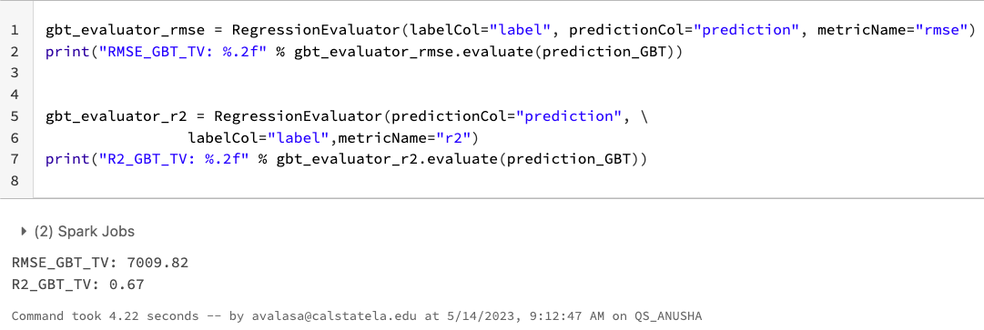

RMSE_GBT_TV: 7009.82

R2_GBT_TV: 0.67

GBT TV Data Training Time = 53.94 Minutes

**Algorithm 3: Random Forest Regression**

**Random Forest with Cross Validation: -**

**1)Create a vector assembler with input columns**

assembler_Rf = VectorAssembler(inputCols = ["year", "city_fuel_economy", "mileage", "owner_count", "highway_fuel_economy", "engine_displacement", "savings_amount"], outputCol="features").setHandleInvalid("skip")



**2) Train the Model**

training_Rf = assembler_Rf.transform(train)

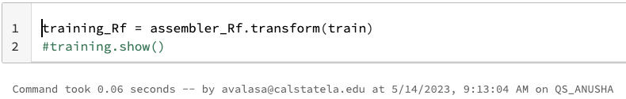

**3) Creating a regressor**

rf = RandomForestRegressor(labelCol='label') #,featuresCol="features", numTrees=10, maxDepth=5

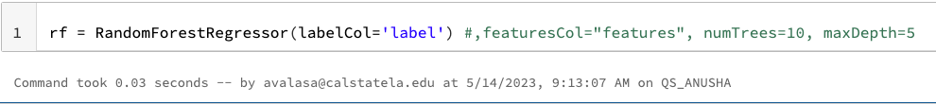

4) **Create a parameter combination to tune the model.**

paramGrid_CV_Rf = ParamGridBuilder()\

.addGrid(rf.maxDepth, [5, 10, 15])\

.addGrid(rf.numTrees, [20, 50, 100])\

.addGrid(rf.minInfoGain, [0.0])\

.build()

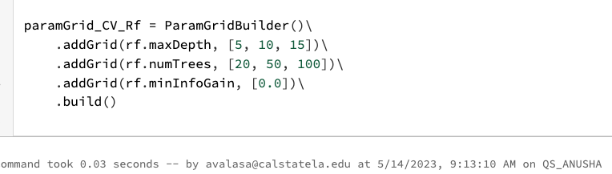

**5)** **Create an evaluator to evaluate a model with R2**

rf_evaluator = RegressionEvaluator(predictionCol="prediction", \

labelCol="label",metricName="r2")

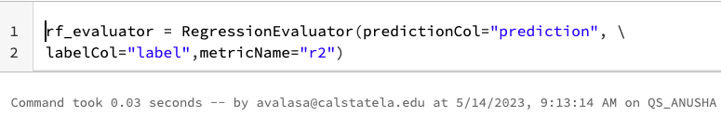

6) **Create a pipeline, which is to sequence the tasks.**

pipeline_rf = Pipeline(stages=[assembler_Rf, rf])

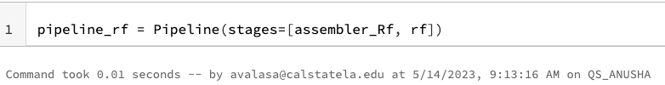

**7) Create a cross-validator to tune the model for the generalization.**

cv_rf = CrossValidator(estimator=pipeline_rf, evaluator=rf_evaluator, estimatorParamMaps=paramGrid_CV_Rf)



**8) Train the Model**

model_CV_rf = cv_rf.fit(train)

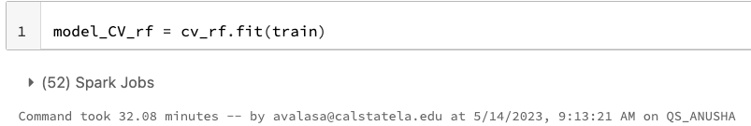

**9) Price Predicton**

prediction_CV_rf = model_CV_rf.transform(test)

predicted_CV_rf = prediction_CV_rf.select("features", "prediction", "label")

predicted_CV_rf.show(10)

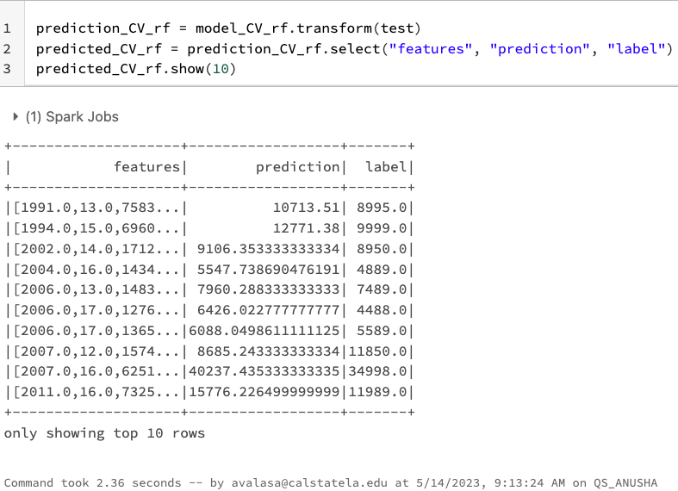

**10) R2 and RMSE for Random Forest Cross Validation**

rf_evaluator_CV_rmse = RegressionEvaluator(labelCol="label", predictionCol="prediction", metricName="rmse")

print("RMSE for CV_RF: %.2f" % rf_evaluator_CV_rmse.evaluate(prediction_CV_rf))

rf_evaluator_CV_r2 = RegressionEvaluator(predictionCol="prediction", \

labelCol="label",metricName="r2")

print("R2 for CV_RF: %.2f" % rf_evaluator_CV_r2.evaluate(prediction_CV_rf))

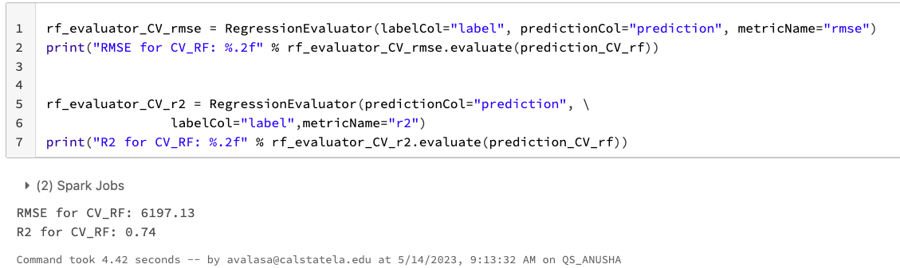

RMSE for CV_RF: 6197.13

R2 for CV_RF: 0.74

Random Forest CV data training time: 32.08 minutes

**Random Forest with Train Validation: -**

**1)Creating ParamGridBuilder along with different parameters**

paramGrid_TV_Rf = ParamGridBuilder()\

.addGrid(rf.maxDepth, [5, 10, 15])\

.addGrid(rf.numTrees, [20, 50, 100])\

.addGrid(rf.featureSubsetStrategy, ['auto', 'sqrt', 'log2'])\

.addGrid(rf.minInfoGain, [0.0])\

.build()

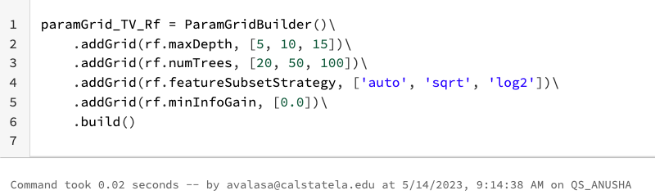

**2)Creating TrainValidation Split**

Tv_rf = TrainValidationSplit(estimator=pipeline_rf, evaluator=rf_evaluator, estimatorParamMaps=paramGrid_TV_Rf, trainRatio=0.9)



**3)Training the Model**

model_tv_rf = Tv_rf.fit(train)

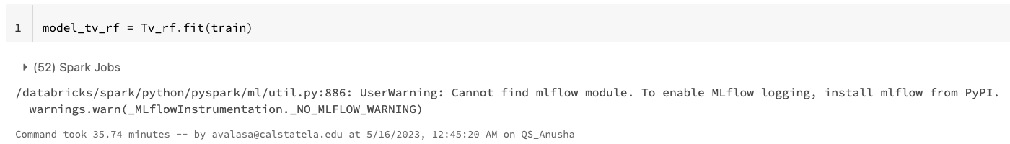

**4)Predicting the Price**

prediction_tv_rf = model_tv_rf.transform(test)

predicted_tv_rf = prediction_tv_rf.select("features", "prediction", "label")

predicted_tv_rf.show(10)

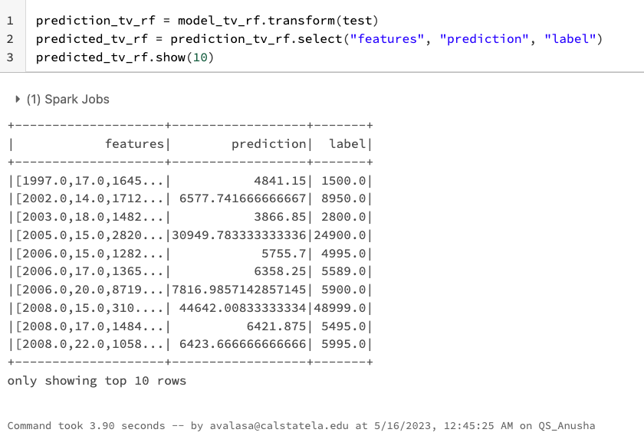

prediction_tv_rf.limit(1000).show()

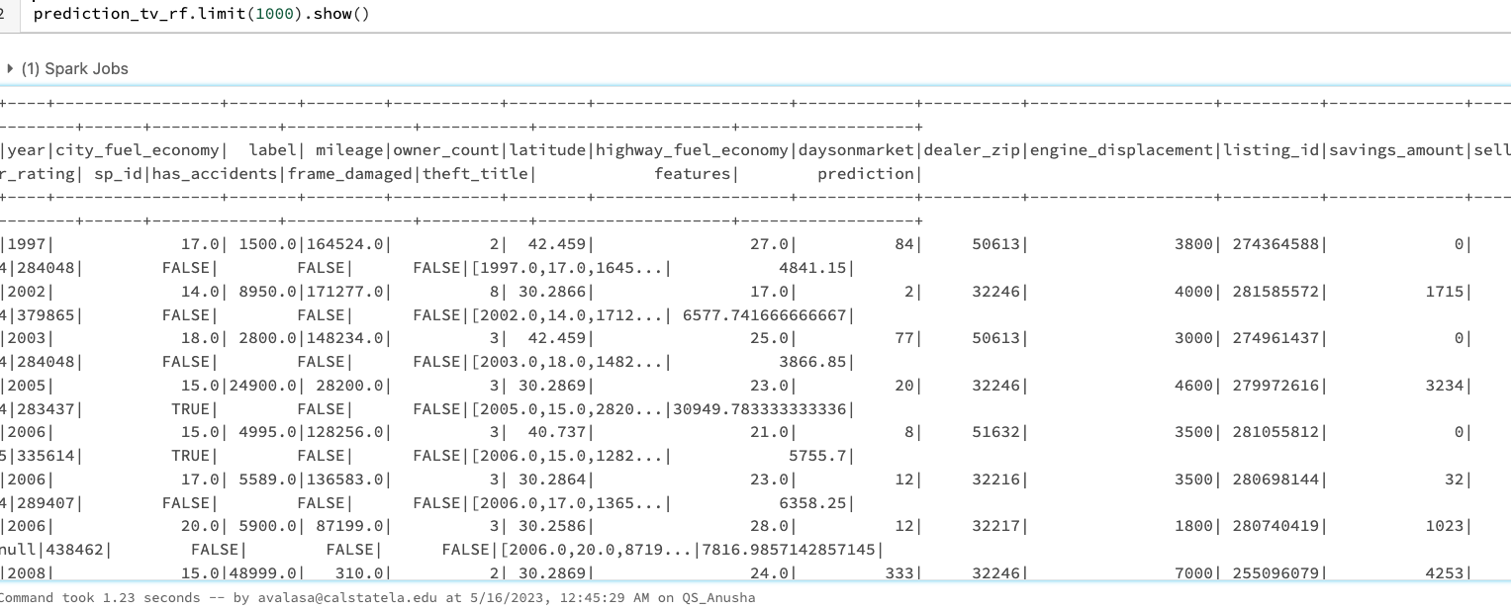

**5)R2 and RMSE for RF Train Validation:-**

rf_tv_evaluator_rmse = RegressionEvaluator(labelCol="label", predictionCol="prediction", metricName="rmse")

print("RMSE for RF_TV: %.2f" % rf_tv_evaluator_rmse.evaluate(prediction_tv_rf))

rf_tv_evaluator_r2 = RegressionEvaluator(predictionCol="prediction", \

labelCol="label",metricName="r2")

print("R2 for RF_TV: %.2f" % rf_tv_evaluator_r2.evaluate(prediction_tv_rf))

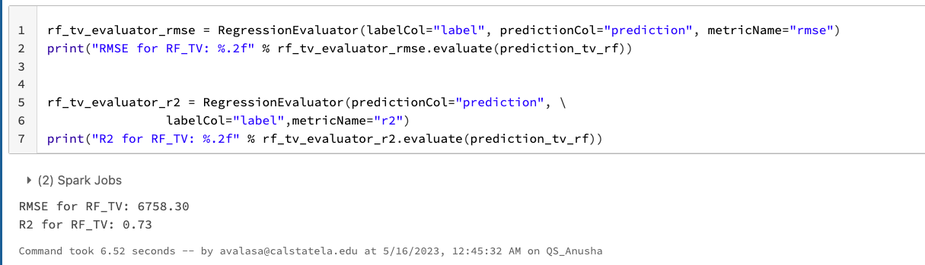

RMSE for TV_RF: 6758.30

R2 for TV_RF: 0.73

Random Forest CV data training time: 35.74 minutes

**Finding the R2 and RMSE without tuning the dataset**

**1)Training the model**

model_RF = pipeline_rf.fit(train)

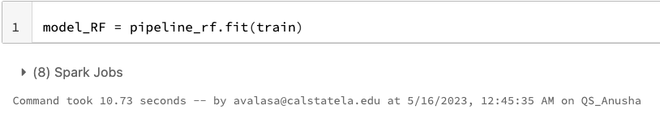

**2)Creating Model**

rfModel = model_RF.stages[-1]

#print(rfModel.toDebugString)

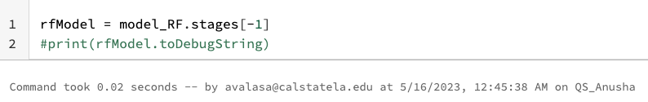

**3)Feature Importance**

featureImp = pd.DataFrame(list(zip(assembler_Rf.getInputCols(), rfModel.featureImportances)), columns=["feature", "importance"])

featureImp.sort_values(by="importance", ascending="False")

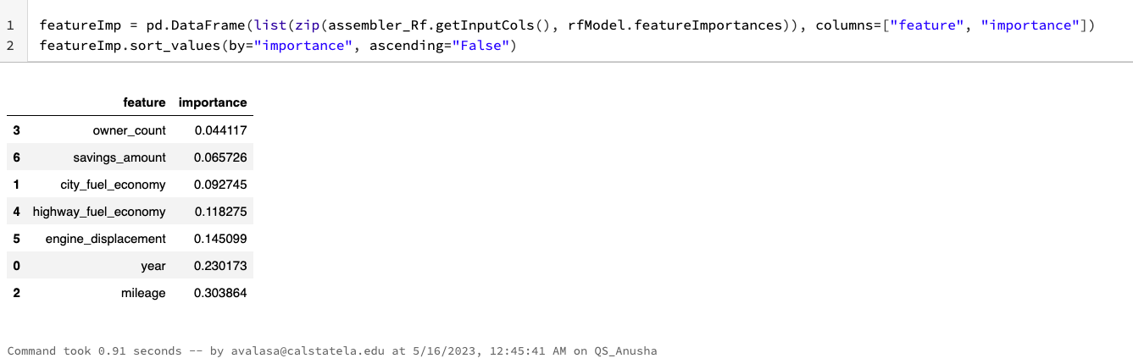

**4)Creating RF regression**

rf = RandomForestRegressor(labelCol="label", featuresCol="features", numTrees=30, maxDepth=15)

# combine stages into pipeline

pipeline_RF_1 = Pipeline(stages= [assembler_Rf, rf])

model_rf = pipeline_RF_1.fit(train)

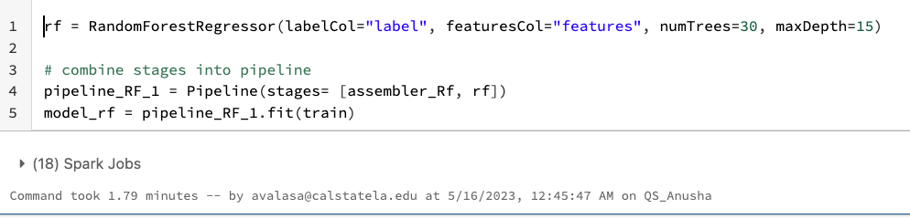

**5)Predicting the Price**

prediction_rf1 = model_rf.transform(test)

predicted_rf1 = prediction_rf1.select("features", "prediction", "label")

predicted_rf1.show(10)

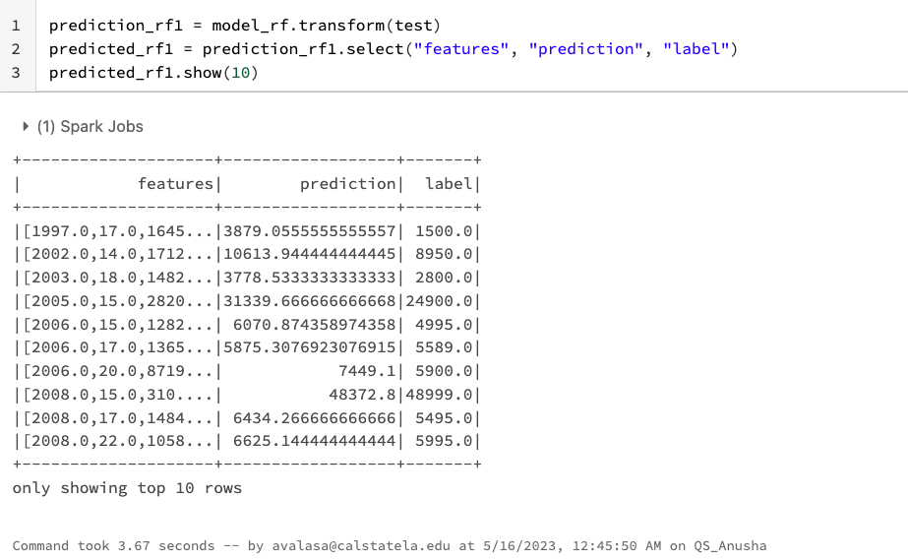

predicted_rf1.limit(1000).show()

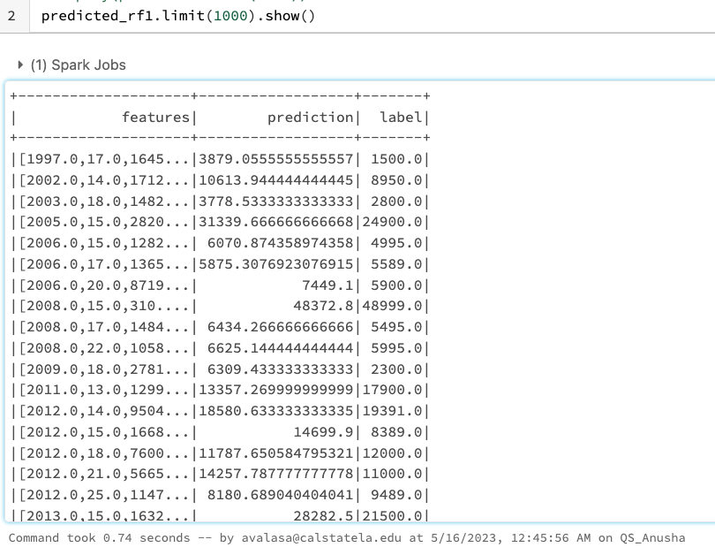

**R2 and RMSE for without tuning the RF: -**

rf_evaluator_rmse = RegressionEvaluator(labelCol="label", predictionCol="prediction", metricName="rmse")

print("RMSE for only RF: %.2f" % rf_evaluator_rmse.evaluate(prediction_rf1))

rf_evaluator_r2 = RegressionEvaluator(predictionCol="prediction", \

labelCol="label",metricName="r2")

print("R2 for only RF: %.2f" % rf_evaluator_r2.evaluate(prediction_rf1))

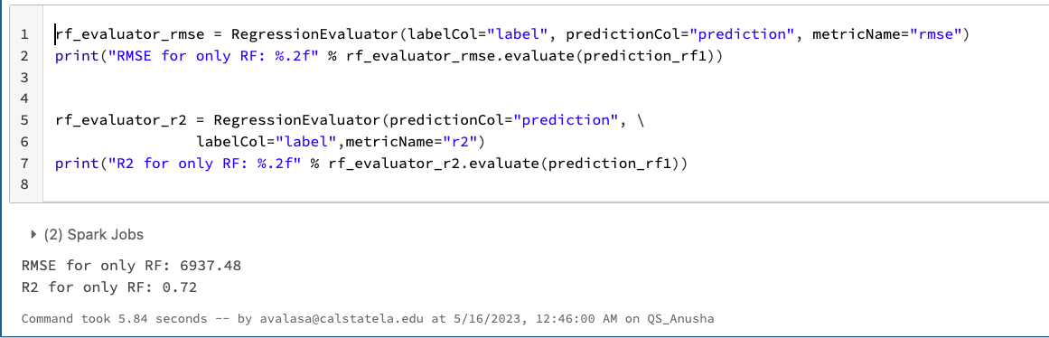

RMSE for TV_RF: 6937.48

R2 for TV_RF: 0.72

Random Forest CV data training time: 10.73 seconds

**Algorithm 4: Factorization Machine** **Regression**

**Factorization Machine** **Regression Cross Validation:**

**1)Creating a vector Assembler**

assembler_fm = VectorAssembler(inputCols = ["year", "city_fuel_economy", "mileage", "owner_count", "highway_fuel_economy", "engine_displacement", "savings_amount"], outputCol="features").setHandleInvalid("skip")



**2)Training Data Frame**

training_fm = assembler_fm.transform(train).select(col("features"))



**3)Creating the Regressor**

fm = FMRegressor(labelCol='label') #,featuresCol="features", numTrees=10, maxDepth=5

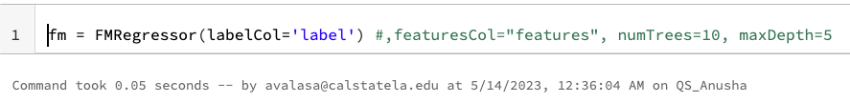

**4)Creating the Param Grid**

paramGrid_CV_fm = ParamGridBuilder() \

.addGrid(fm.stepSize, [0.1, 1]) \

.build()

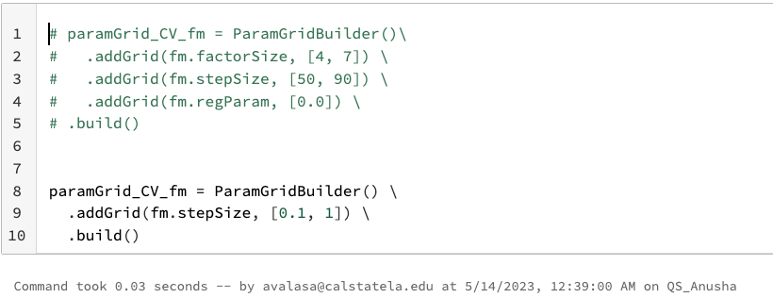

**5)Creating Evaluator**

from pyspark.ml.evaluation import RegressionEvaluator

fm_evaluator = RegressionEvaluator(predictionCol="prediction", \

labelCol="label",metricName="r2")

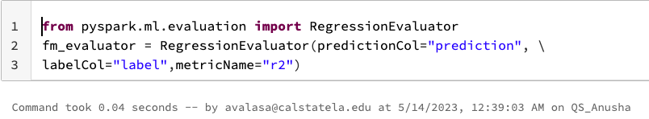

**7)Creating Pipeline**

pipeline_fm = Pipeline(stages=[assembler_fm, fm])

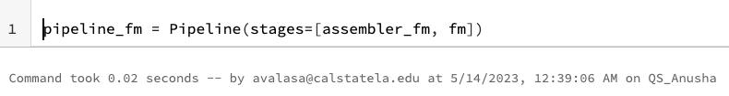

**8)Creating the Cross Validator**

cv_fm = CrossValidator(estimator=pipeline_fm, evaluator=fm_evaluator, estimatorParamMaps=paramGrid_CV_fm)



**9)Training Cross Validator FM**

model_fm = cv_fm.fit(train)

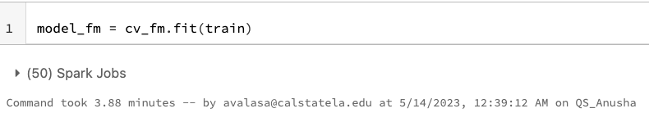

**10)Predicting the Price**

prediction_fm = model_fm.transform(test)

predicted_fm = prediction_fm.select("features", "prediction", "label")

predicted_fm.show(10)

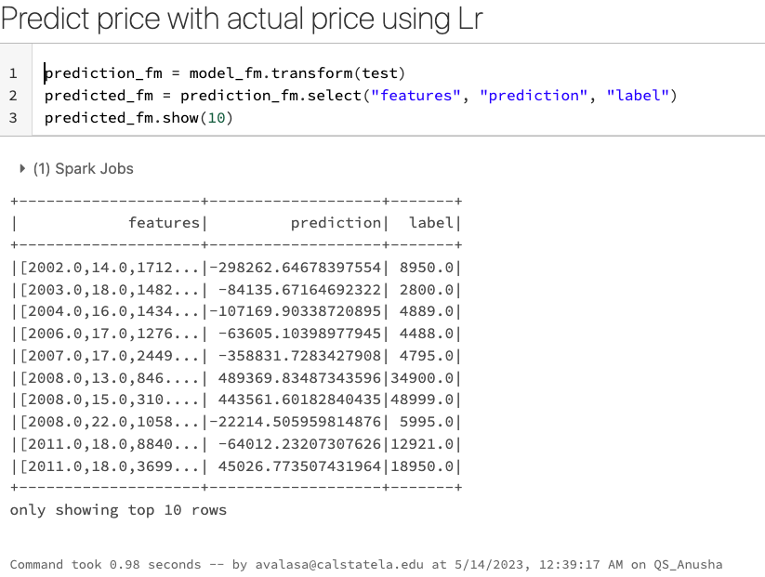

**10)RMSE AND R2 For FM Cross Validation**

fm_cv_evaluator_rmse = RegressionEvaluator(labelCol="label", predictionCol="prediction", metricName="rmse")

print("RMSE for FM_CV: %.2f" % fm_cv_evaluator_rmse.evaluate(prediction_fm))

fm_cv_evaluator_r2 = RegressionEvaluator(predictionCol="prediction", \

labelCol="label",metricName="r2")

print("R2 for FM_CV: %.2f" % fm_cv_evaluator_r2.evaluate(prediction_fm))

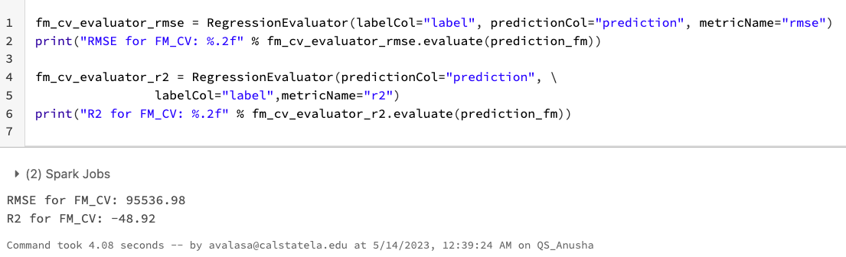

RMSE for FM_CV: 95536.98

R2 for FM_CV: -48.92

Training time: 3.88 minutes

**FM_TrainValidationSplit: -**

**1)Creating a Paramgrid builder with parameters**

paramGrid_TV_fm = ParamGridBuilder()\

.addGrid(fm.factorSize, [8]) \

.addGrid(fm.stepSize, [0.01, 0.1]) \

.addGrid(fm.regParam, [0.01, 0.1]) \

.build()

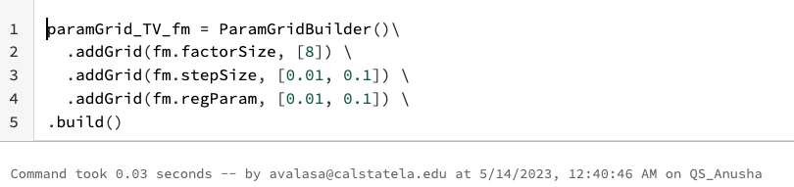

**2)Creating the Train Validation Split**

fm_tv = TrainValidationSplit(estimator=pipeline_fm, evaluator=fm_evaluator, estimatorParamMaps=paramGrid_TV_fm, trainRatio=0.8)

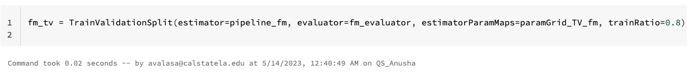

**3)Training the model**

model_tv_fm = fm_tv.fit(train)

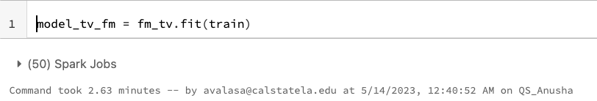

**4)Predicting the Price**

prediction_tv_fm = model_tv_fm.transform(test)

predicted_tv_fm = prediction_tv_fm.select("features", "prediction", "label")

predicted_tv_fm.show(10)

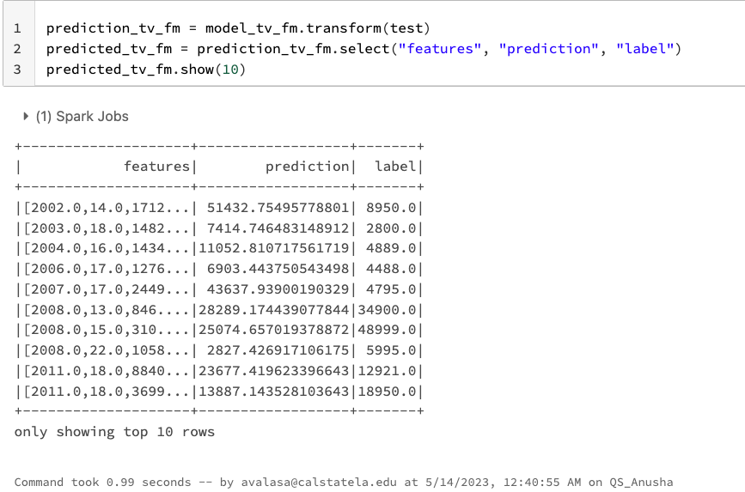

**5)R2 and RMSE for FM TV: -**

fm_tv_evaluator_rmse = RegressionEvaluator(labelCol="label", predictionCol="prediction", metricName="rmse")

print("RMSE for FM_TV: %.2f" % fm_tv_evaluator_rmse.evaluate(prediction_tv_fm))

fm_tv_evaluator_r2 = RegressionEvaluator(predictionCol="prediction", \

labelCol="label",metricName="r2")

print("R2 for FM_CV: %.2f" % fm_tv_evaluator_r2.evaluate(prediction_tv_fm))

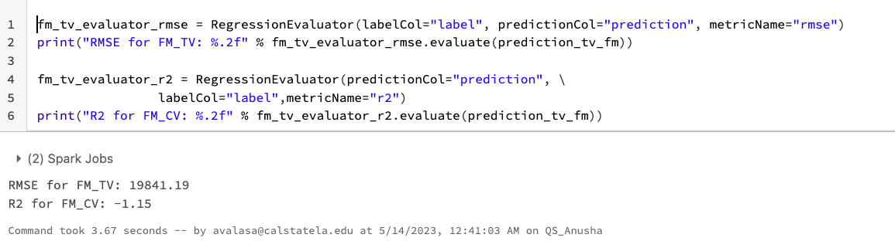

RMSE for TV_RF: 19841.19

R2 for TV_RF: -1.15

Random Forest CV data training time: 2.63 minutes

**Algorithm 5: Logistic Regression**

**1)Creating the Schema**

flightSchema = StructType([

StructField("year", IntegerType(), False),

StructField("price", IntegerType(), False),

StructField("mileage", StringType(), False),

StructField("owner_count", IntegerType(), False),

StructField("seller_rating", IntegerType(), False),

StructField("city_fuel_economy", IntegerType(), False),

StructField("highway_fuel_economy", IntegerType(), False),

StructField("daysonmarket", IntegerType(), False),

StructField("dealer_zip", IntegerType(), False),

StructField("engine_displacement", IntegerType(), False),

StructField("listing_id", IntegerType(), False),

StructField("savings_amount", IntegerType(), False),

StructField("seller_rating", IntegerType(), False),

StructField("sp_id", IntegerType(), False),

])

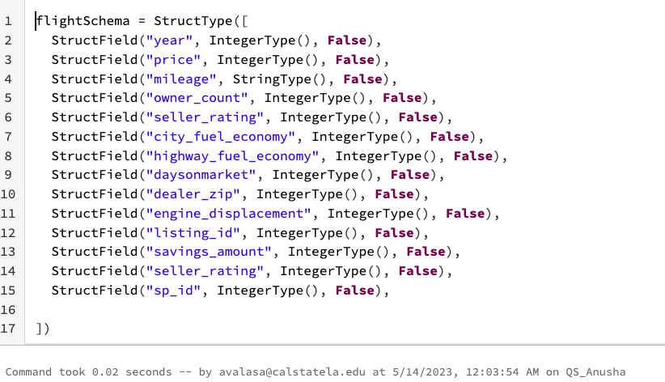

**2)Selecting the input columns which are different from the above algorithms as here predicting yes or no**

(df2.select("year", "city_fuel_economy", col("price").alias("label"), "mileage", "owner_count", "latitude", "highway_fuel_economy", "daysonmarket", "dealer_zip", "engine_displacement", "listing_id", "savings_amount", "seller_rating","sp_id").limit(10)).show()

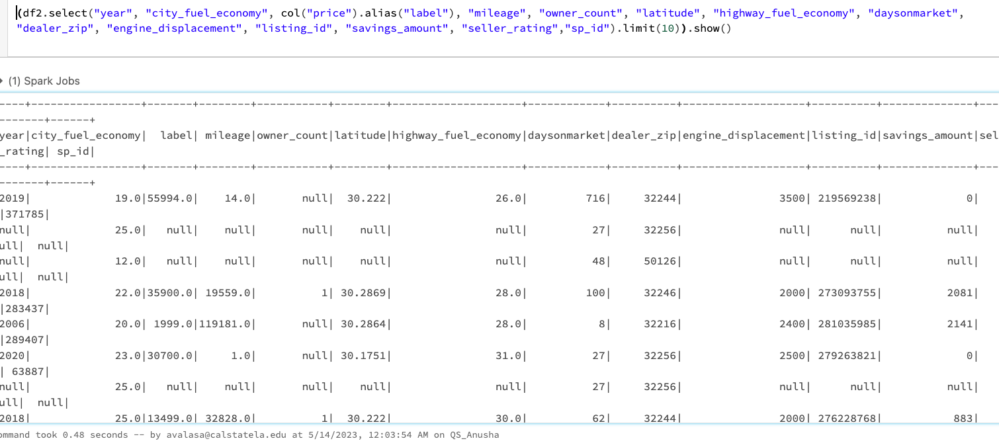

df2 = df2.filter(col("price") < 100000)

#display(df2.limit(10))

(df2.limit(10)).show()

df23 = df2.select("year", "city_fuel_economy", ((col("price") > 10000).cast("Double").alias("label")), "mileage", "owner_count", "highway_fuel_economy", "daysonmarket", "dealer_zip", "engine_displacement", "listing_id", "savings_amount", "seller_rating","sp_id")



**3)Dropping the null values**

df23.na.drop(subset=["label", "year", "city_fuel_economy", "mileage","owner_count", "highway_fuel_economy", "daysonmarket", "dealer_zip", "engine_displacement", "listing_id", "savings_amount", "seller_rating","sp_id"])

df23.show()

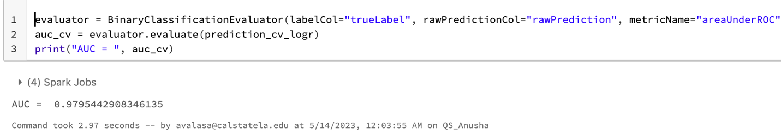

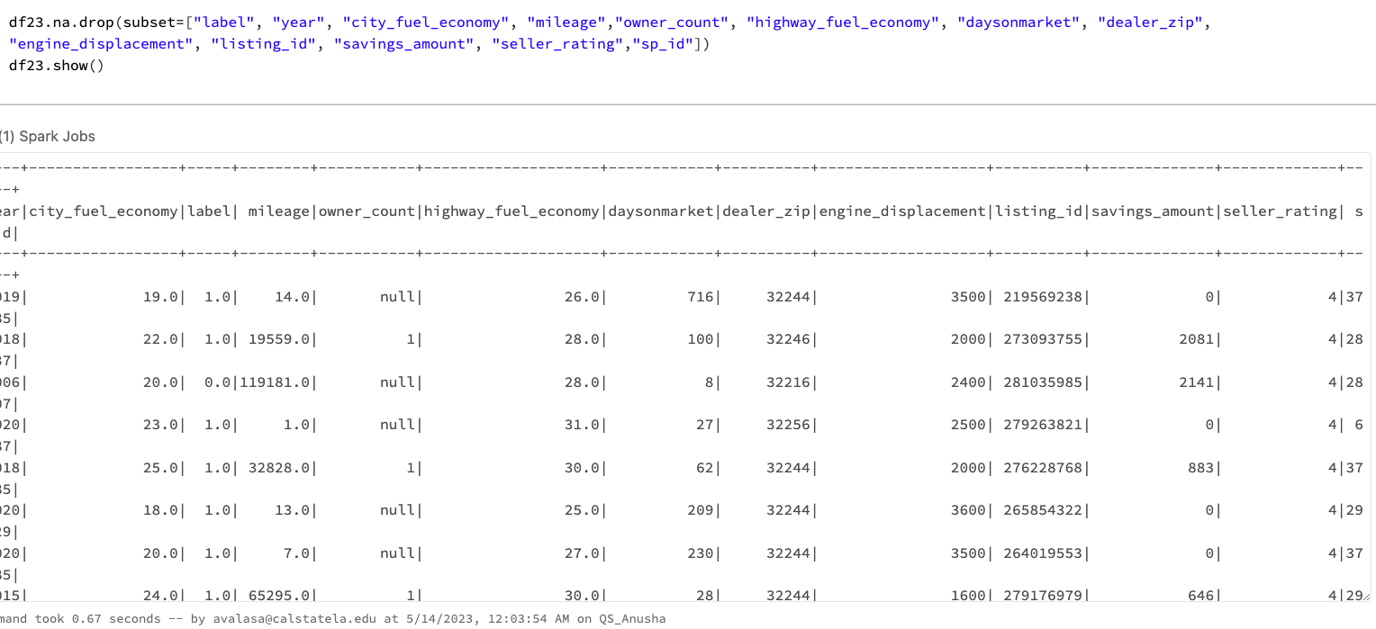

**4) Splitting the data**

splits = df23.randomSplit([0.7, 0.3])

train = splits[0]

test = splits[1].withColumnRenamed("label", "trueLabel")

train_rows = train.count()

test_rows = test.count()

print("Training Rows:", train_rows, " Testing Rows:", test_rows)

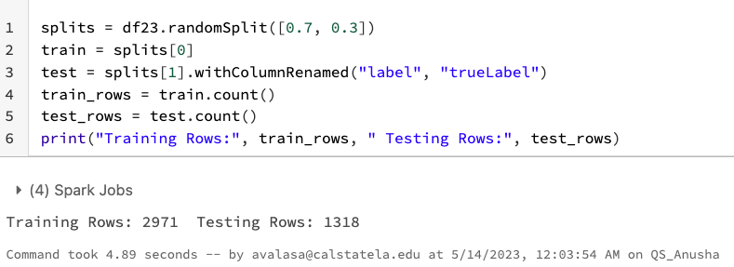

**5) Creating the vector assembler and adding all the input features like vector indexer and min max scaler to the vector assembler. Creating the logistic regression and pipeline**

catVect = VectorAssembler(inputCols = ["mileage","year", "owner_count", "city_fuel_economy", "highway_fuel_economy", "daysonmarket", "dealer_zip", "engine_displacement", "listing_id", "savings_amount", "seller_rating","sp_id"], outputCol="catFeatures").setHandleInvalid("skip")

catIdx = VectorIndexer(inputCol = catVect.getOutputCol(), outputCol = "idxCatFeatures").setHandleInvalid("skip")

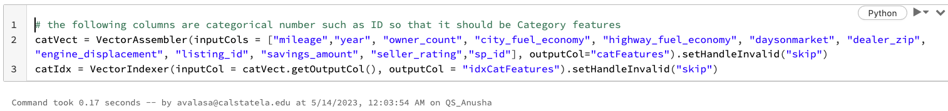

numVect = VectorAssembler(inputCols = ["mileage"], outputCol="numFeatures")

# number vector is normalized

minMax = MinMaxScaler(inputCol = numVect.getOutputCol(), outputCol="normFeatures")

featVect = VectorAssembler(inputCols=["idxCatFeatures", "normFeatures"], outputCol="features") #="features1")

# number vector is normalized: this changes the accuracy of precision a little

# minMax2 = MinMaxScaler(inputCol = featVect.getOutputCol(), outputCol="features")

lr = LogisticRegression(labelCol="label",featuresCol="features",maxIter=10,regParam=0.3)

# Pipeline process the series of transformation above, which is 7 transformation

pipeline = Pipeline(stages=[catVect, catIdx, numVect, minMax, featVect, lr]) #minMax2, lr])

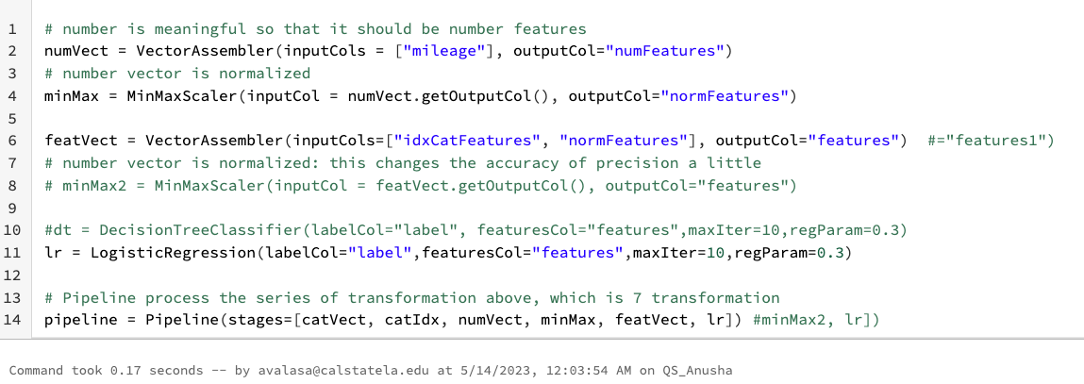

**6) Creating the Param grid with different parameters**

paramGrid = (ParamGridBuilder() \

.addGrid(lr.regParam, [0.01, 0.5]) \

.addGrid(lr.elasticNetParam, [0.0, 0.5]) \

.addGrid(lr.maxIter, [1, 5]) \

.build())

#paramGrid = ParamGridBuilder().addGrid(lr.regParam, [0.3, 0.1, 0.01]).addGrid(lr.maxIter, [10, 5]).addGrid(lr.threshold, [0.35, 0.30]).build()

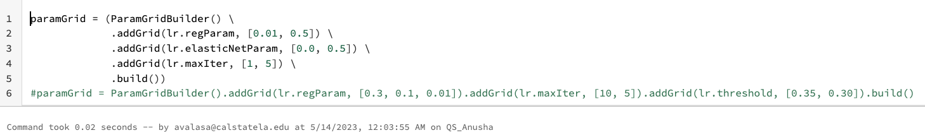

**7) Creating the Evaluator**

cv_logr = CrossValidator(estimator=pipeline, evaluator=BinaryClassificationEvaluator(), estimatorParamMaps=paramGrid)

model_Cv_logr = cv_logr.fit(train)

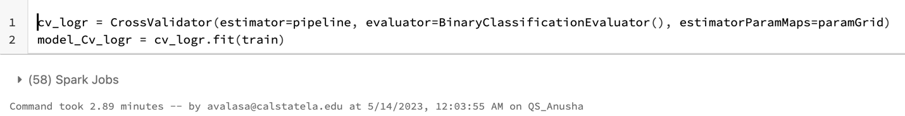

**8) Predicting the data with input columns**

prediction_cv_logr = model_Cv_logr.transform(test)

predicted_cv_logr = prediction_cv_logr.select("features", "prediction", "probability", "trueLabel")

predicted_cv_logr.show(100, truncate=False)

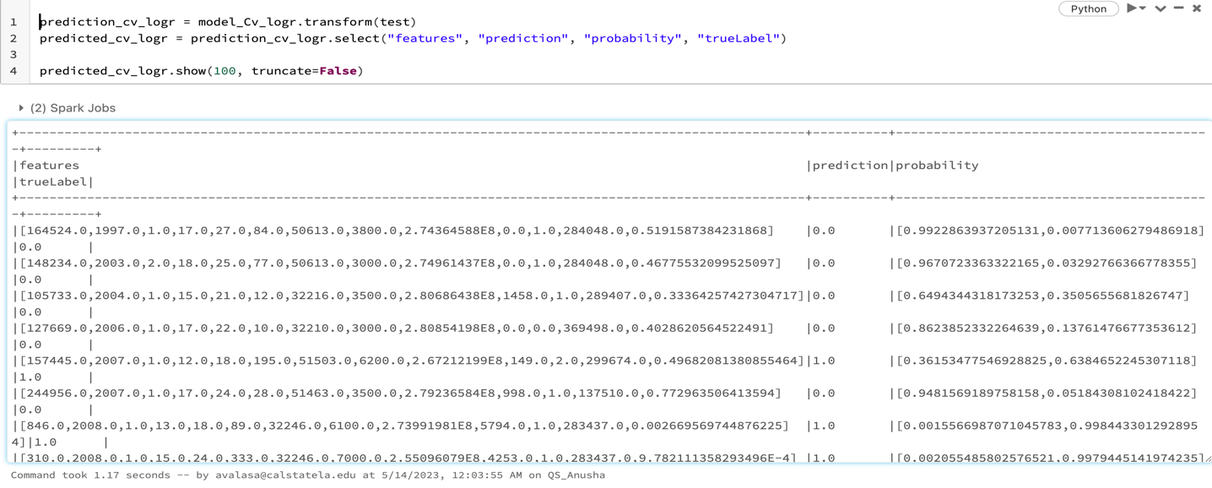

**9)Predicting the data which has True Positives, False Positives, True Negatives, False negatives**

tp = float(predicted_cv_logr.filter("prediction == 1.0 AND truelabel == 1").count())

fp = float(predicted_cv_logr.filter("prediction == 1.0 AND truelabel == 0").count())

tn = float(predicted_cv_logr.filter("prediction == 0.0 AND truelabel == 0").count())

fn = float(predicted_cv_logr.filter("prediction == 0.0 AND truelabel == 1").count())

metrics = spark.createDataFrame([

("TP", tp),

("FP", fp),

("TN", tn),

("FN", fn),

("Precision", tp / (tp + fp)),

("Recall", tp / (tp + fn))],["metric", "value"])

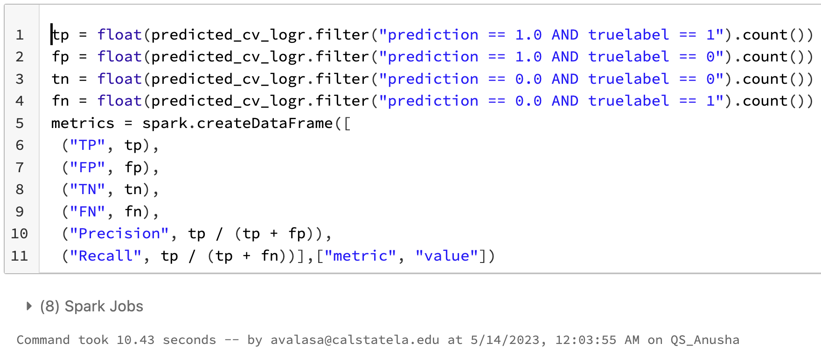

**10) To see the metrics**

**metrics.show()**

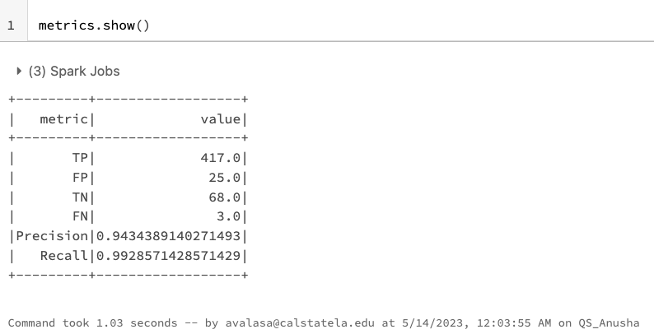

**11) Predicting whether user can buy this or not**

prediction_cv_logr.select("rawPrediction", "probability", "prediction", "trueLabel").show(100, truncate=False)

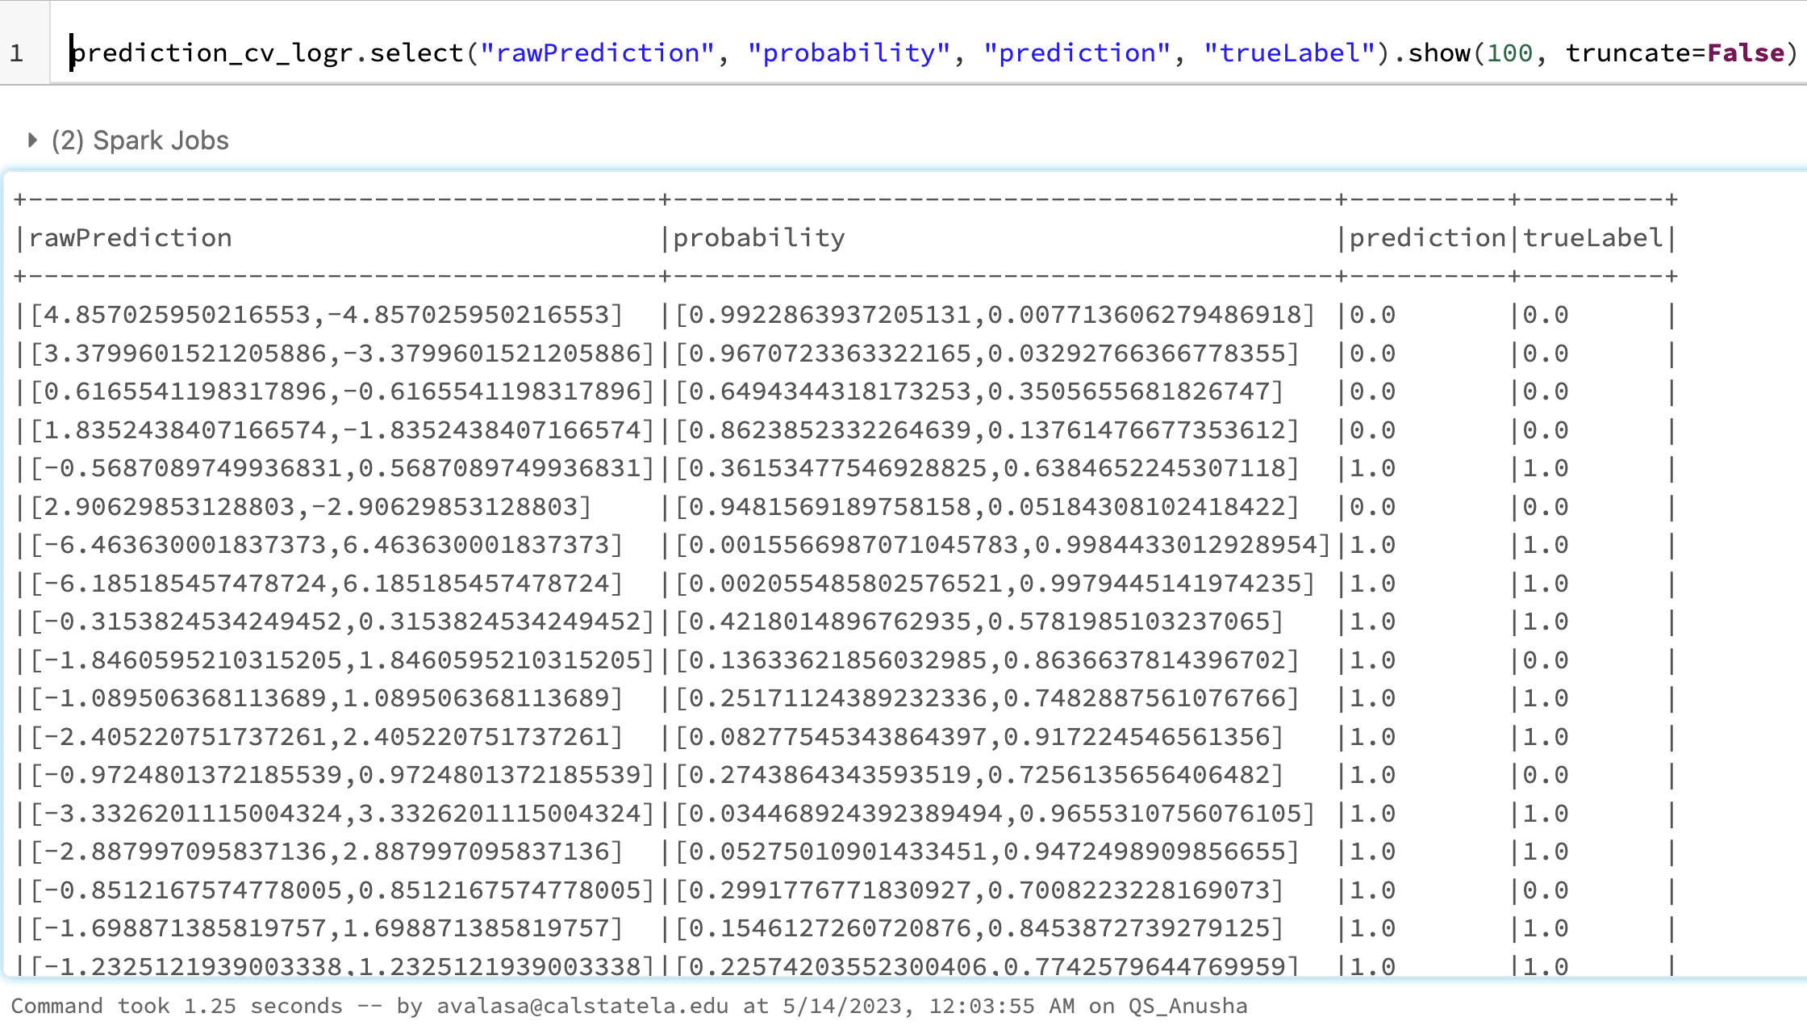

**12) Finding the AUC**

evaluator = BinaryClassificationEvaluator(labelCol="trueLabel", rawPredictionCol="rawPrediction", metricName="areaUnderROC")

auc_cv = evaluator.evaluate(prediction_cv_logr)

print("AUC = ", auc_cv)

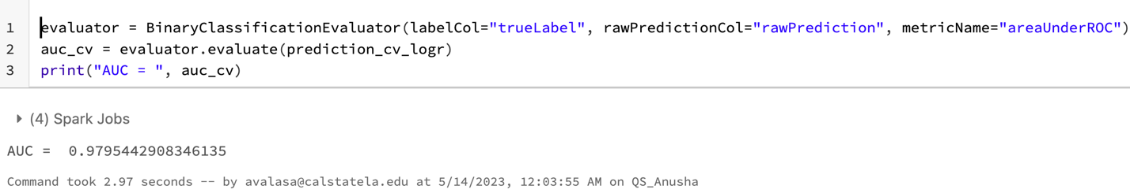

AUC = 0.97

Training time: 3 Minutes

**TrainValidationSplit For Logistic Regression: -**

**1)Creating the Train Validation for logistic Regression**

cv = TrainValidationSplit(estimator=pipeline, evaluator=BinaryClassificationEvaluator(), estimatorParamMaps=paramGrid, trainRatio=0.8)

model = cv.fit(train)

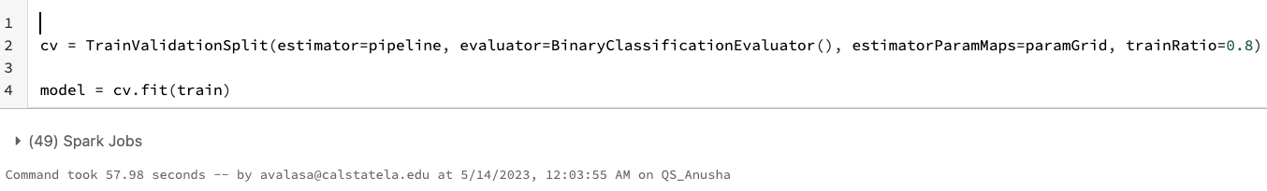

**2)Predicting the probability**

prediction = model.transform(test)

predicted = prediction.select("features", "prediction", "probability", "trueLabel")

predicted.show(100, truncate=False

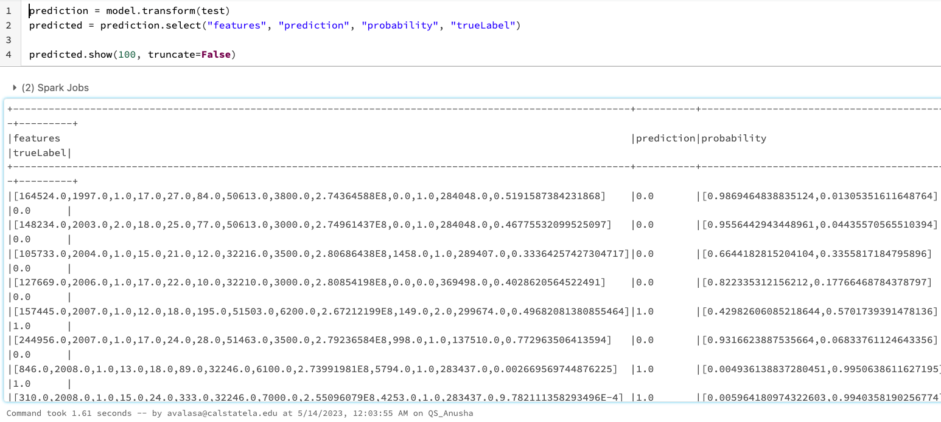

**3) Predicting the data which has True Positives, False Positives, True Negatives, False negatives**

tp = float(predicted.filter("prediction == 1.0 AND truelabel == 1").count())

fp = float(predicted.filter("prediction == 1.0 AND truelabel == 0").count())

tn = float(predicted.filter("prediction == 0.0 AND truelabel == 0").count())

fn = float(predicted.filter("prediction == 0.0 AND truelabel == 1").count())

metrics = spark.createDataFrame([

("TP", tp),

("FP", fp),

("TN", tn),

("FN", fn),

("Precision", tp / (tp + fp)),

("Recall", tp / (tp + fn))],["metric", "value"])

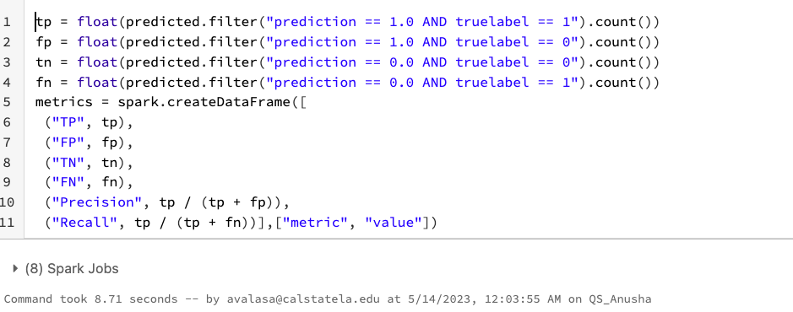

**4) To see the metrics**

metrics.show()

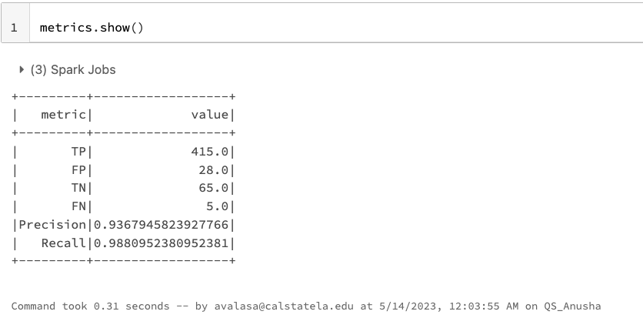

**5) Predicting the probability of wether the user can buy this car or not**

prediction.select("rawPrediction", "probability", "prediction", "trueLabel").show(100, truncate=False)

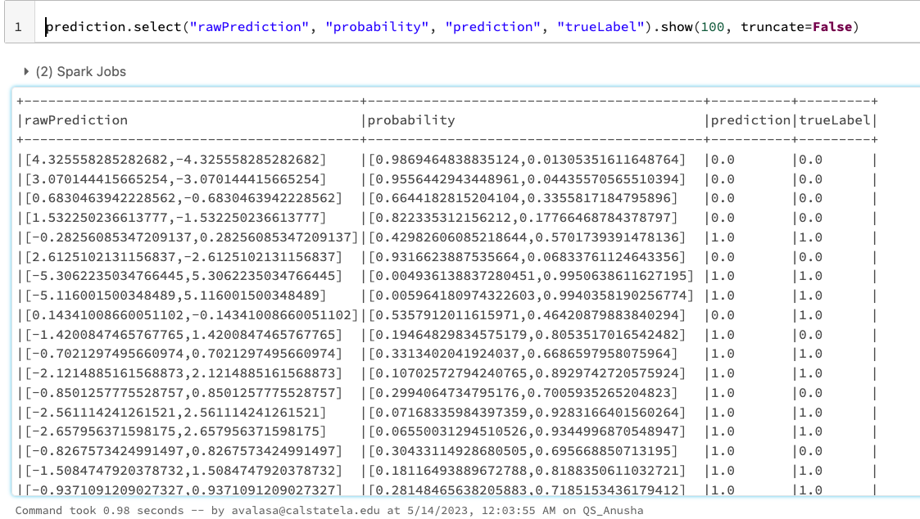

**6)Finding the AUC**

evaluator = BinaryClassificationEvaluator(labelCol="trueLabel", rawPredictionCol="rawPrediction", metricName="areaUnderROC")

auc = evaluator.evaluate(prediction)

print("AUC = ","{:.2f}".format(auc))

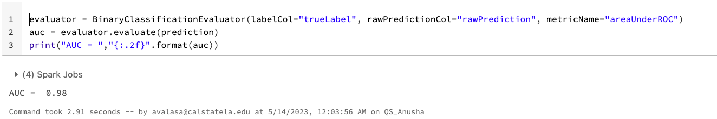

AUC = 0.98

Training time = 1minute

**To run the whole 2GB used_cars_data_set.csv with Pyspark Submit.**

1)Download .py file from the Databricks

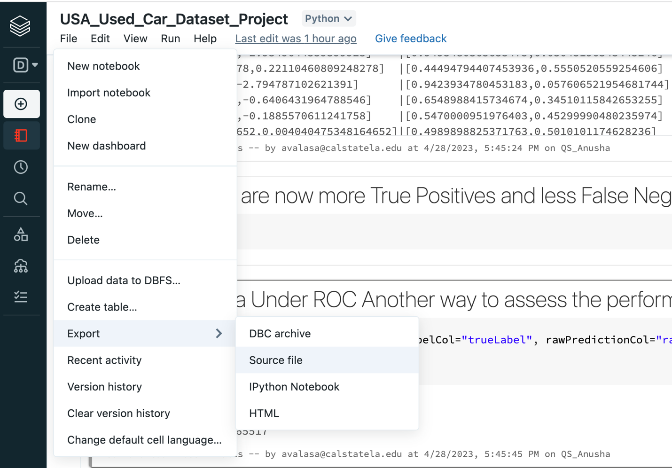

**PYSPARK SUBMIT**

**STEP 1:** Connect to the Hadoop Spark cluster.

If you use Linux or Mac computers, you can use the Finder app to search the terminal with the keyword Term to find it. Then it will show you the terminal that you can use.

If you are working with a Windows laptop, you must use git bash and paste the ssh command to connect to the Hadoop Spark cluster.

You can download and install Git Bash using this link: <https://git-scm.com/downloads>

You must use your Cal State LA email account name (avalasa) to log in to the cluster; in a terminal, you must type in the following ssh shell command to connect.

NOTE: Use your username “avalasa” to login into the Oracle big data server

ssh [avalasa@144.24.53.159](mailto:avalasa@144.24.53.159)

To enter the password, type in your username as password and press enter.

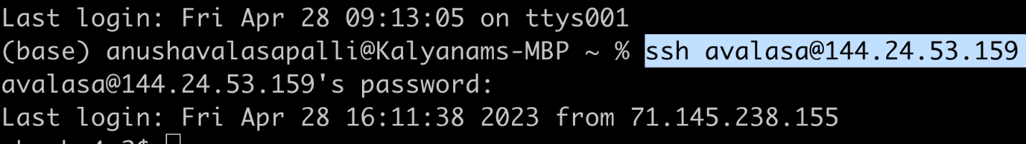

Now you will be logged in.

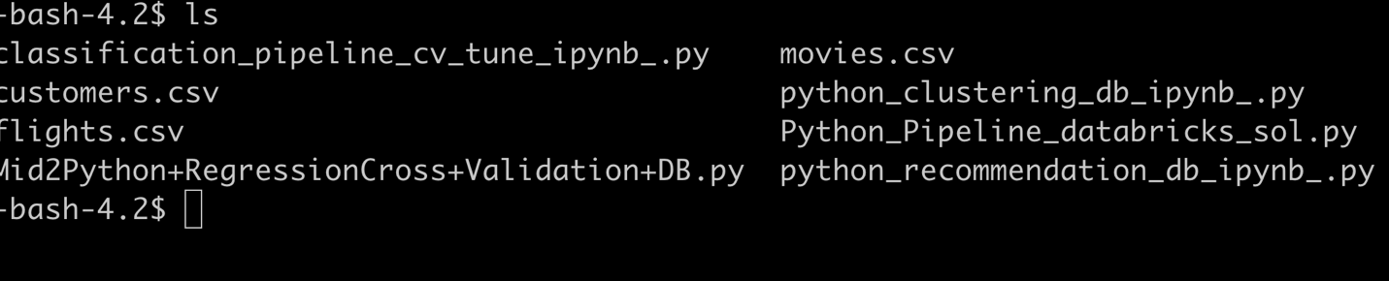

**ZEPPELIN:**

Suppose you use Zeppelin to write and run the code instead of data bricks. You have to open another window in the terminal or git bash, add the below command, and give the password the same as the user name.

ssh -N -L 8080:localhost:8080 [avalasa@144.24.53.159](mailto:avalasa@144.24.53.159)

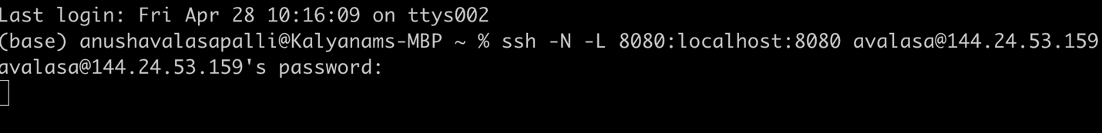

Click on this URL to connect to the port 8080 for Zeppelin <http://localhost:8080/> to import the files.

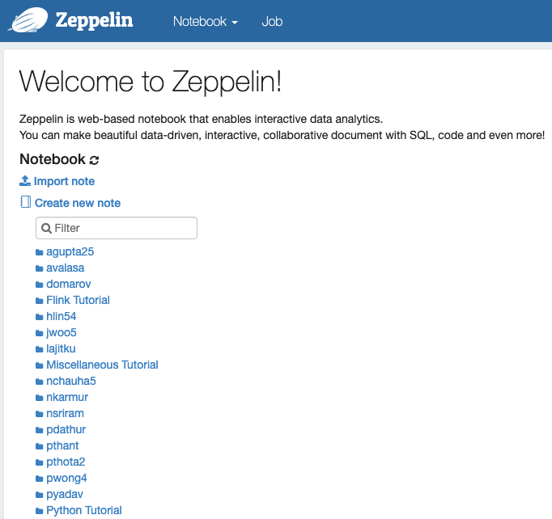

**STEP 2:** transfer files from the local to Hadoop local server; open a new window and paste the below command.

scp downloads/US_Used_Cars_Data.csv [avalasa@144.24.53.159](mailto:avalasa@144.24.53.159):~

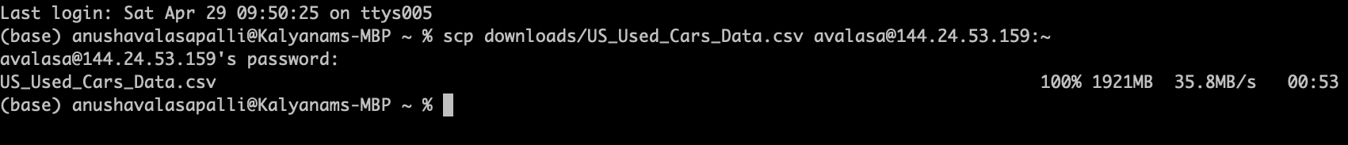

**STEP 3:** Use the below command to upload the US_Used_Cars_Data.csv file from the local server to HDFS.

hdfs dfs -put US_Used_Cars_Data.csv.

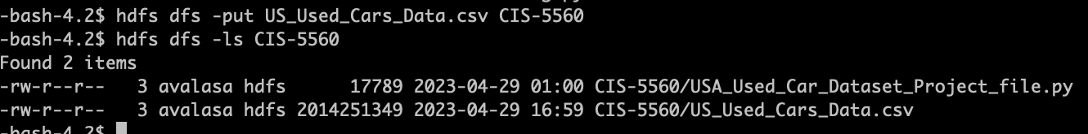



To check that the file is uploaded in the hdfs, use the hdfs dfs -ls command

Now we can see the US_Used_Cars_Data.csv file in the hdfs.

**STEP 4:** **Create a directory, “CIS5560” to put the file to HDFS**.

1. a. Run the following HDFS command to create the directory in HDFS.
   * 1. hdfs dfs -mkdir CIS-5560



1. **b. Next, you can run the following shell command to put the file in the respective directory.**
2. hdfs dfs -put US_Used_Cars_Data.csv CIS-5560/



**To Check that the US_Used_Cars_Data.csv file is uploaded into the CIS-5560**



**Now we have to upload the .py file to the hdfs which is the same as how we did for US_Used_Cars_Data.csv**

scp downloads/ usa_used_car_dataset_project.py [avalasa@144.24.53.159:~](mailto:avalasa@144.24.53.159:~)

hdfs dfs -put usa_used_car_dataset_project.py.

hdfs dfs -put usa_used_car_dataset_project.py CIS-5560/

hdfs dfs -ls CIS-5560



**To open the usa_used_car_dataset_project.py file in the hdfs**

vi usa_used_car_dataset_project.py

Changing PYSPARK_CLI = True

**STEP 5:** **To run the usa_used_car_dataset_project.py in spark-submit**

spark-submit --conf spark.driver.memory=8g --conf spark.executor.memory=8g usa_used_car_dataset_project.py



Change the file_location as "/user/avalasa/ US_Used_Cars_Data.csv "

file_location = "/user/avalasa/ US_Used_Cars_Data.csv "

**Results From Pyspark Submit**

**1)Linear Regression**

1. **Cross Validation**

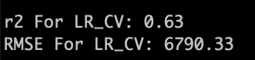

1. **Train Validation**

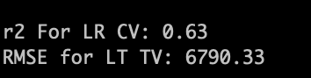

**2)Gradient Boost Tree Regression**

1. **Cross Validation**

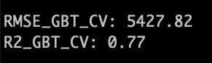

1. **Train Validation**

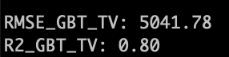

**3)Random Forest Regression**

1. **Cross Validation**

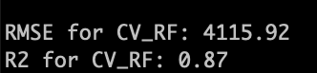

1. **Train Validation**

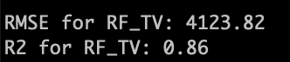

**4)Factorization Machine Regressor**

1. **Cross Validation**

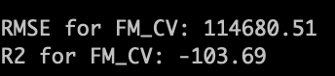

1. **Train Validation**

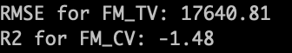

**5) Logistic Regression**

1. **Cross Validation**

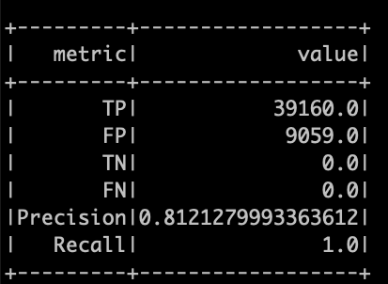

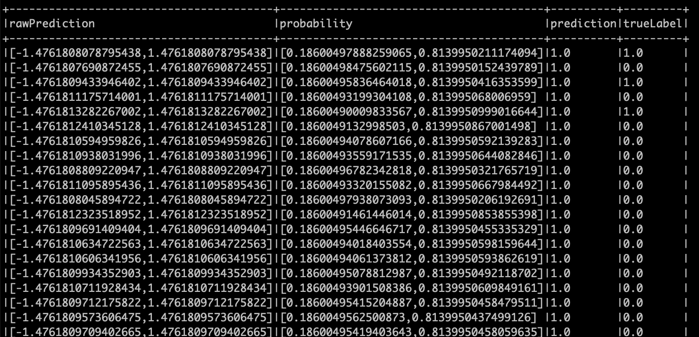



1. **Train Validation**

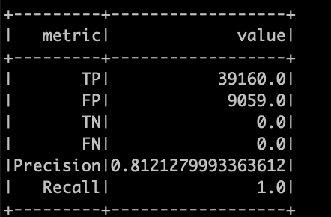

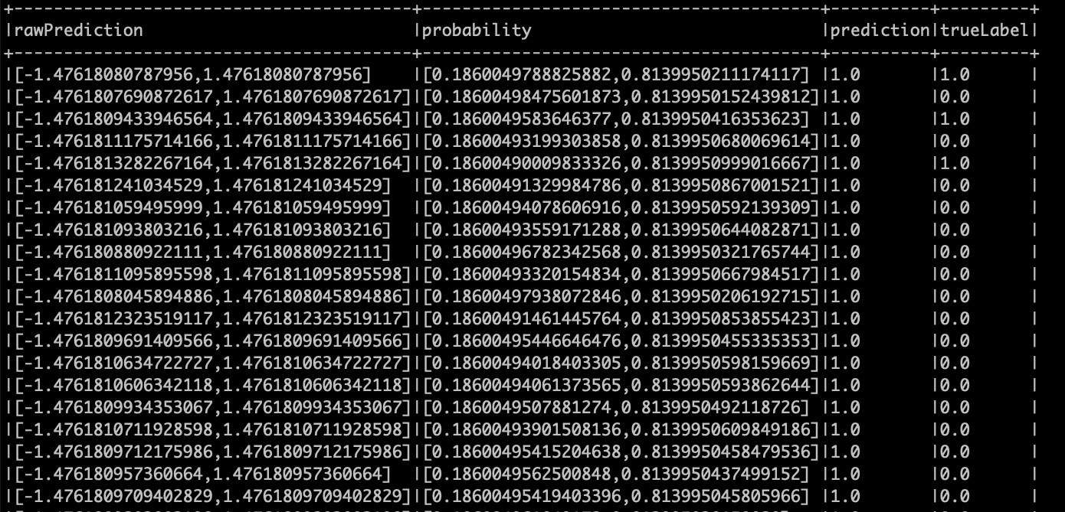

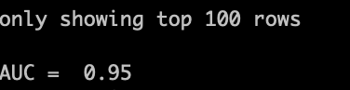

**Compare the Results**

Once you run all the Regression models, you can compare the results of all the Regression models. The Results should look something like the below. According to the Comparison table below. We can arrange various Regression Algorithms in the below order.

Based on time:

GBT> RF>LR>FM> LGR (GBT taking the most time and Logistic Regression taking the least)

Based on accuracy:

RF> LGR> GBT>LR> FM (RF having the best accuracy and FM having the least)

|  |  |  |  |  |
| --- | --- | --- | --- | --- |
| **Algorithm** | **Results CV** | **Results TV** | **Time is taken to fit the model.**  **For CV**  **(For data bricks)** | **Time is taken to fit the model.**  **For TV**  **(For data bricks)** |
| Linear Regression (LR) | Databricks  R2: 0.61  RMSE:7693.73  Spark Submit  R2: 0.63  RMSE: 6790.33 | Databricks  R2: 0.61  RMSE:7693.73  Spark Submit  R2:0.63  RMSE:6790.33 | 58.50 seconds | 20.46 seconds |
| Random Forest Regression (RF) | Databricks  R2: 0.74  RMSE:6197.13  Spark Submit  R2: 0.87  RMSE:4115.92 | Databricks  R2: 0.73  RMSE:6758.30  Spark Submit  R2: 0.86  RMSE: 4123.82 | 32.08 minutes | 35.74 minutes |
| Gradient Boost Tree Regression (GBT) | Databricks  R2: 0.67  RMSE: 7059.37  Spark Submit  R2: 0.77  RMSE:5427.82 | Databricks  R2: 0.67  RMSE: 7009.82  Spark Submit  R2: 0.80  RMSE:5041.78 | 12.81 Minutes | 53.94 Minutes |
| Factorization Machine Regression | Databricks  R2: -48.92  RMSE:95536.98  Spark Submit  R2: -103.69  RMSE:114680.51 | Databricks  R2: -1.15  RMSE:19841.19  Spark Submit  R2: -1.48  RMSE:17640.81 | 3.88 minutes | 2.63 minutes |
| Logistic Regression | Databricks  Precision: 0.94  Recall:0.97  AUC:0.99  Spark Submit  Precision: 0.81  Recall: 1.0  AUC:0.95 | Databricks  Precision: 0.93  Recall:0.98  AUC:0.98  Spark Submit  Precision: 0.8  Recall: 1.0  AUC: 0.95 | 3 Minutes | 1Minute |

Result:

After working with all the algorithms in data bricks to predict the price of the used cars in the USA we compared the RMSE and R2 results and decided that Random Forest regressor is the best algorithm for our dataset. When we worked with, the Random Forest regressor, for the cross validation we got the R2 value as 0.74 and RMSE as 6197.13 and for the train validation we got R2 as 0.73 and RMSE as 6758.30. But the run time for the Random Forest regressor is high but the accuracy is high. The second-best model is the Gradient Boost Tree Regressor where for the cross validation we got the R2 value as 0.67 and RMSE as 7059.37 and for the train validation we got R2 as 0.67 and RMSE as 7009.82. But the run time for the train validation is too high which is 53.94 minutes. The Linear regression has almost similar accuracy like the Gradient boost tree where for the cross validation we got the R2 value as 0.61 and RMSE as 7693.73 and for the train validation we got R2 as 0.61 and RMSE as 7693.73. But the run time is very low when compared to any other model. The last model is the factorization machine regressor which isn’t much useful for our dataset where we got negative R2 values. The Logistic regressor model is also useful as the recall, precision and AUC values are accurate through which the customer can decide if they are getting a fair deal or not. When compared to the data bricks results, the Spark submit results are more accurate and the R2 values are almost near to 1 and the RMSE values are also low for all the algorithms.

**References:**

1.URL of Data Source:

<https://www.kaggle.com/datasets/ananaymital/us-used-cars-dataset>

2. URL of your GitHub:

<https://github.com/anushavalasapalli-97/CIS-5560-US_USED_CARS_PROJECT->

3. URL of References:

<https://spark.apache.org/docs/2.2.0/ml-pipeline.html>

<https://spark.apache.org/docs/latest/ml-tuning.html>

4. Databricks Html File URL:

<file:///Users/anushavalasapalli/Downloads/US_Used_Cars_Dataset_Project.html>